

Colonial First State

DevOps UserManual -

DMT

Jan 2023

Document title

|  |  |
| --- | --- |
| **Project Title** | CFS Core IT |
| **Author** | Avanade:  Achroo Batta/Abaigail Artagame |
| **Reviewer** | <Insert> |
| **Approver** | <Insert> |
| **Current Version** | 1.0 |
| **File Name** | DevOps UserManual-DMT |
| **Publication Date** |  |

Revision history

|  |  |  |  |
| --- | --- | --- | --- |
| Version | Date | Author | Changes |
| 1.0 | 23/1/2023 | Achroo Batta/Abaigail Artagame | Initial Version |
| 1.1 | 01/03/2023 | Achroo | Changes |
| 1.2 | 02/03/2023 | Rhoda | Added E2E Process |
| 1.3 | 02/03/2023 | Abby/Rhoda/Nelvin/Achroo/Joshua | Added FAQs |
| 1.4 | 14/04/2023 | Achroo | CR -OnDemand |
| 1.4 | 14/04/2023 | Abby | Trigger/Housekeeping Pipeline Updates |
| 1.5 | 20/04/2023 | Abby | Updates |

Table of Contents

1 Introduction 1

1.1 Purpose 1

1.2 Project Description 1

2 Core infrastructure, technical details, and dependencies 2

3 GitHub Action – CI Job 3

4 Core Services Pipeline 4

4.1 Existing CFS Vnet pipeline 4

4.2 Core services 4

5 Trigger Pipeline 5

5.1 Prerequisites 5

5.2 Work Item Task Creation Instructions 6

5.3 Trigger Pipeline Stages 8

5.4 YAML Files and Scripts 9

6 OnDemand Pipeline 11

7 OnDemand Pipeline - CR 16

8 Master Script Powershell 18

8.1 Functions being run by the Master script. 18

8.2 Scripts definition and needed parameters. 19

8.3 Migration Flow 22

8.4 Script Monitoring 22

8.5 Definition of terms 23

9 HouseKeeping Pipeline 25

9.1 Housekeeping Pipeline Stages 29

9.2 YAML Files and Scripts 30

10 End-to-End Testing 31

10.1 Input Parameter File 31

10.1.1 Sample Input Parameter Files 34

10.1.2 Sample Input Parameter Files - CR 36

10.2 Trigger End-to-End Testing 36

10.3 FAQs 39

10.3.1 Trigger Pipeline 39

10.3.2 OnDemand Pipeline 50

10.3.3 Powershell Scripts 58

10.3.4 Housekeeping Pipeline 63

# Introduction

## Purpose

The purpose of this document is to provide information about Data Migration Tool Migration Landing Zone (DMT MLZ).

## Project Description

CFS Data Migration – DMT is an automated solution for data extraction processes for internal and external recipients based on parameters defined by business users. All these pipelines are part of the AUSUP organization and Core-IT project. This solution uses the following set of pipelines to complete the extraction process:

1. GitHub action CI job – GitHub CI job lint Bicep and PowerShell code, creates NuGet package and pushes to Azure Artifactory on completion.
2. Core Service Pipeline – This pipeline in combination with Virtual Network pipeline (existing CFS) defines core one-time services for DMT project in the Backoffice subscription.
3. Trigger Pipeline – This pipeline gets triggers when a task is created in Azure Boards in Core-IT project under AUSUP organization. This pipeline reads information mentioned in the parameters excel attached to the task. Also, this pipeline triggers the On-Demand pipeline with the required set of parameters. This pipeline will notify the CFS personnel about triggering of OnDemand pipeline.
4. OnDemand Pipeline: - This pipeline consists of multiple stages which will deploy adhoc components in CFS Backoffice network and triggers master script as a process on VM, which will carry out extraction process based on the input file provided. The OD pipeline will notify CFS personnel with username, Destination Sftp password and sshkey via email.
5. House-Keeping Pipeline: - This will be triggered by PowerShell last scripts on completion of extraction process, and this will delete Adhoc components like VM, Disks, Diagnostic Storage Accounts and system-roles assigned to VM. This will also notify CFS personnel about the location of the extracted file.

# Core infrastructure, technical details, and dependencies

1. Production
   1. Service Principles used
   2. Security groups to gain access to Repositories
   3. PAT Tokens
   4. Mailbox used for email
   5. Any key dependencies that was setup to make Pipeline work end to end
2. Non Production
   1. Service Principles used
   2. Mailbox used for email
   3. Any key dependencies that was setup to make Pipeline work end to end
3. Anything else to be added, think about it, if someone takes over, that has no background, any key info that will help the person understand the dependencies on solution to get up to speed quicker.

# GitHub Action – CI Job

This job lints the bicep and powershell scripts and scans the code for vulnerabilities. On successful completion, it creates a nuget package and pushes this package under the name of CFS.Core.BKOF to Azure Artifactory. As soon as, code is pushed to develop or main branch, CI jobs will be triggered automatically.

**CIjob** - cfs-data-migration/.github/**workflows**/

**Screenshots**

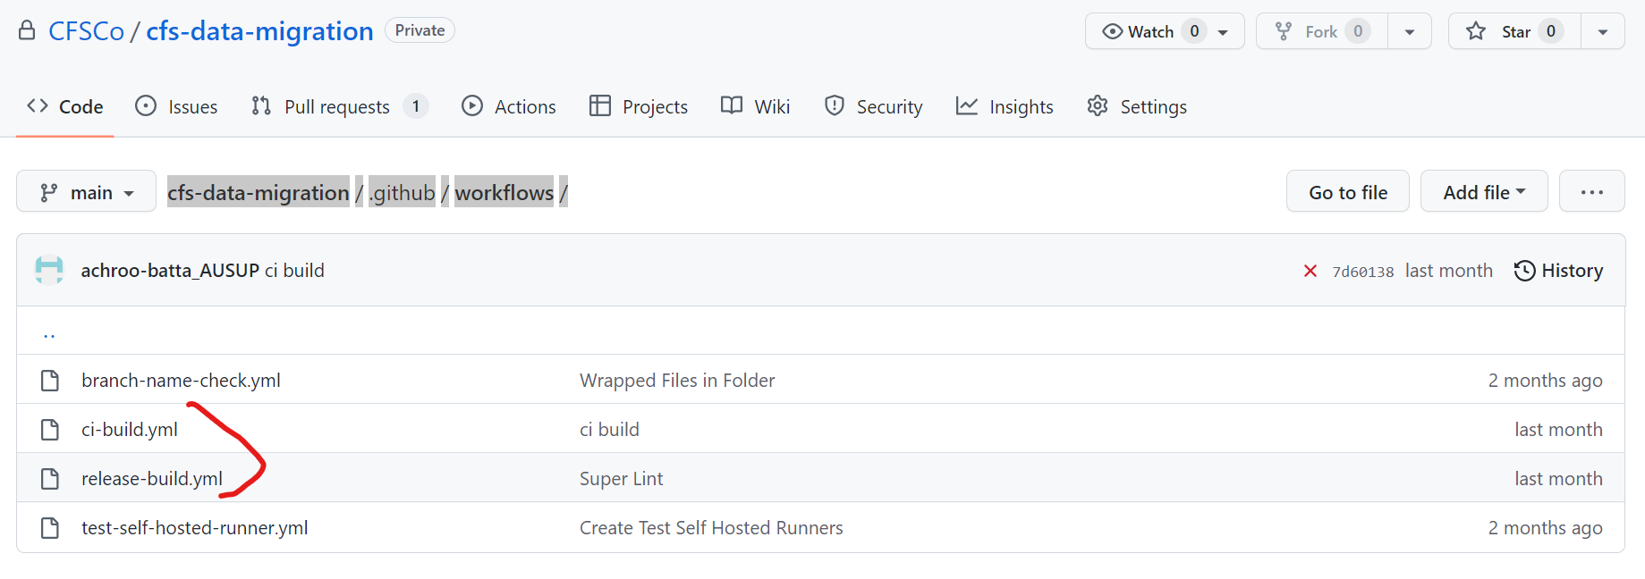

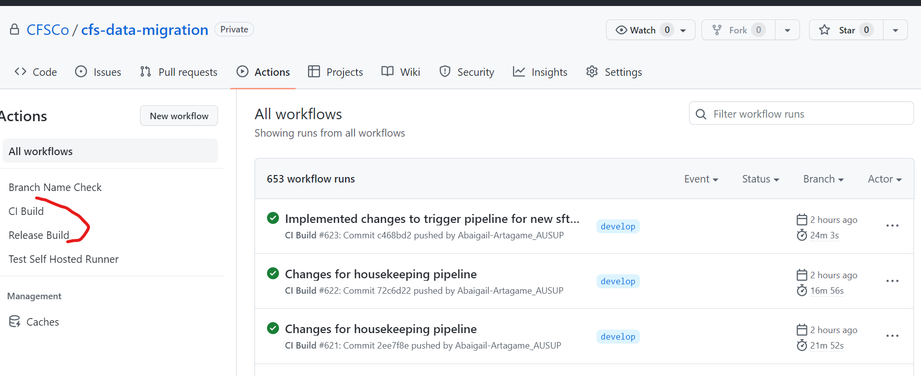

# Core Services Pipeline

This pipeline in combination with Virtual Network pipeline (existing CFS) defines core one-time services for DMT project in the Backoffice subscription.

## Existing CFS Vnet pipeline

To define Virtual network and related components in production raise a CFS Service Now ticket for Lalit Namdev/Dhanalakshmi’ team, because we share network with R5. This is required to maintain single source of truth in Github. For Non-prod, we have our own network, so use coreservice pipeline to deploy networking components.

## Core services

After creation of Networking components in non-production, this pipeline will create PrivateDNSZone, Source Storage Account, Dependency Storage Account, Key Vault. User needs to choose branch, select environment, and tick components which needs to be deployed and it will create those components in Azure. This is one time creation in respective environment and use bicep templates to deploy components.

**Bicep** - cfs-data-migration/CFS.Core.BKOF/**bicep-templates**/

**Pipeline** - [cfs-data-migration](https://github.com/CFSCo/cfs-data-migration)/[CFS.Core.BKOF](https://github.com/CFSCo/cfs-data-migration/tree/main/CFS.Core.BKOF)/[azure-pipelines](https://github.com/CFSCo/cfs-data-migration/tree/main/CFS.Core.BKOF/azure-pipelines)/DMCoreServicesPipeline.yml

**Screenshots**

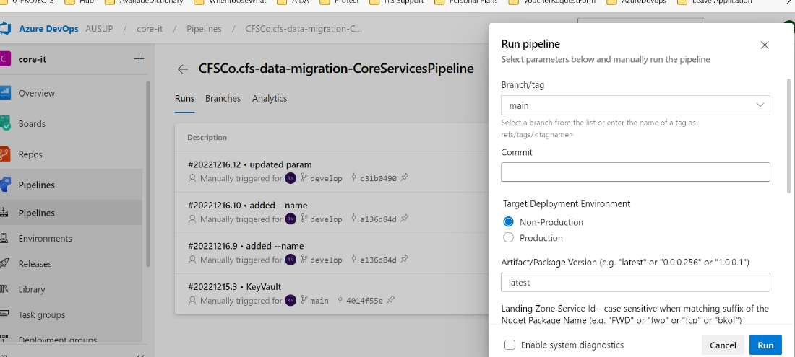

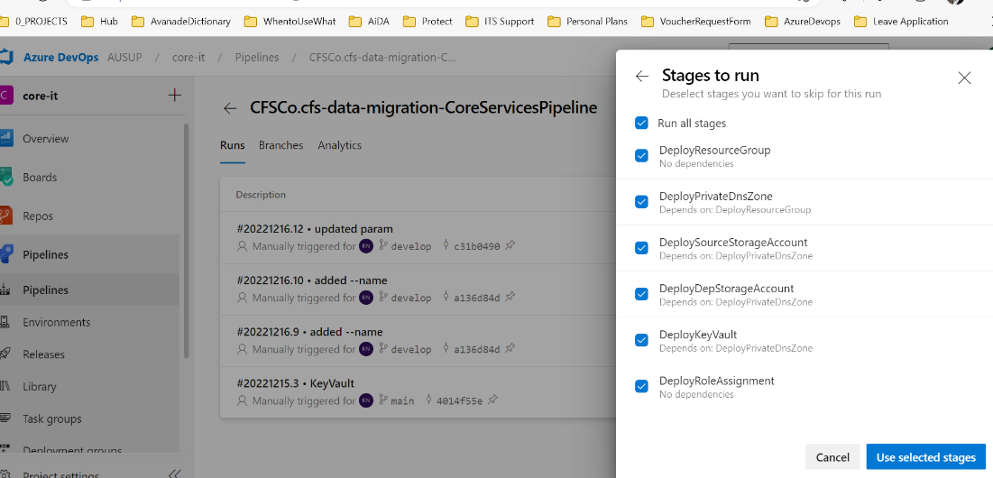

# Trigger Pipeline

This pipeline is triggered by an Azure DevOps Service Connection (Incoming Web Hook) that is triggered by an Azure DevOps Service Hook (Web Hook) with Azure DevOps work item task creation or update event. After completion it will trigger the OnDemand pipeline.

## Prerequisites

* Service Hook Subscriptions (Web Hook)

This will trigger the Trigger Pipeline if the following event is created:

* + Work Item created with a tag:
    - request: non-production
  + Work Item created with a tag:
    - request: production
  + Work Item updated with a tag:
    - no attachment

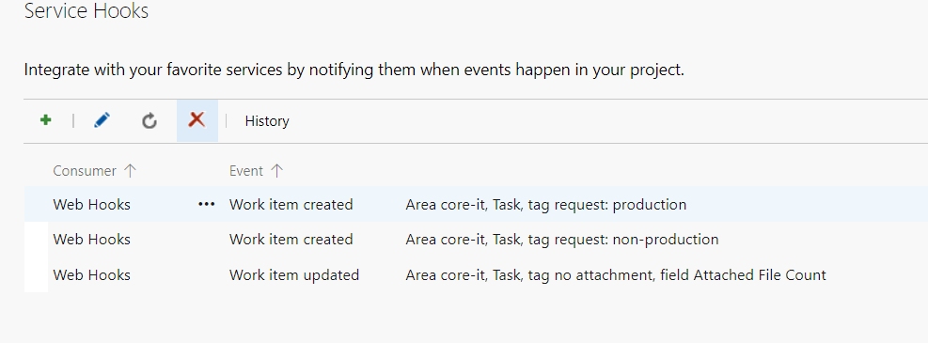

***Note: These should be modified if the Task will be created in a different Area path.*** 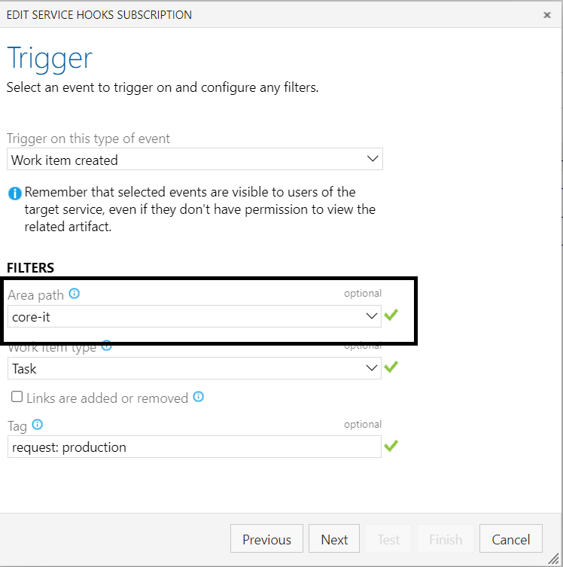

* Incoming WebHook Service Connection 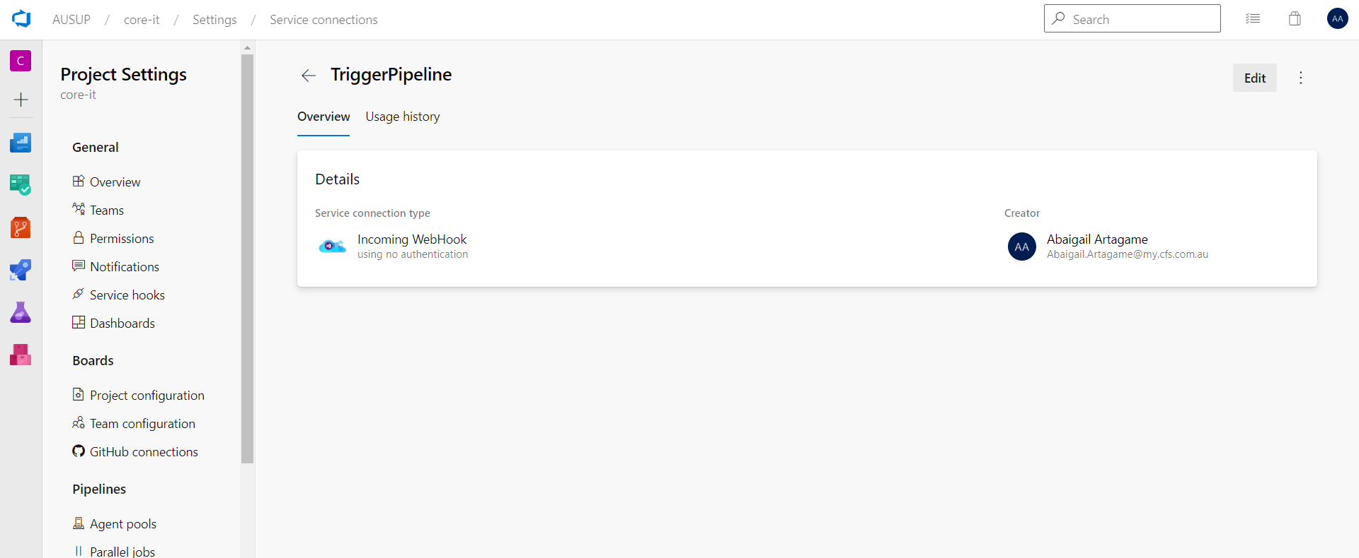
* Personal Access Token – For Azure DevOps Authentication
* Existing Product Backlog Item (optional)

This will act as a parent work Item for the newly created work item task (request ticket).

* Input Parameter File

## Work Item Task Creation Instructions

* 1. Open [core-it](https://dev.azure.com/AUSUP/core-it) project in the desired browser. 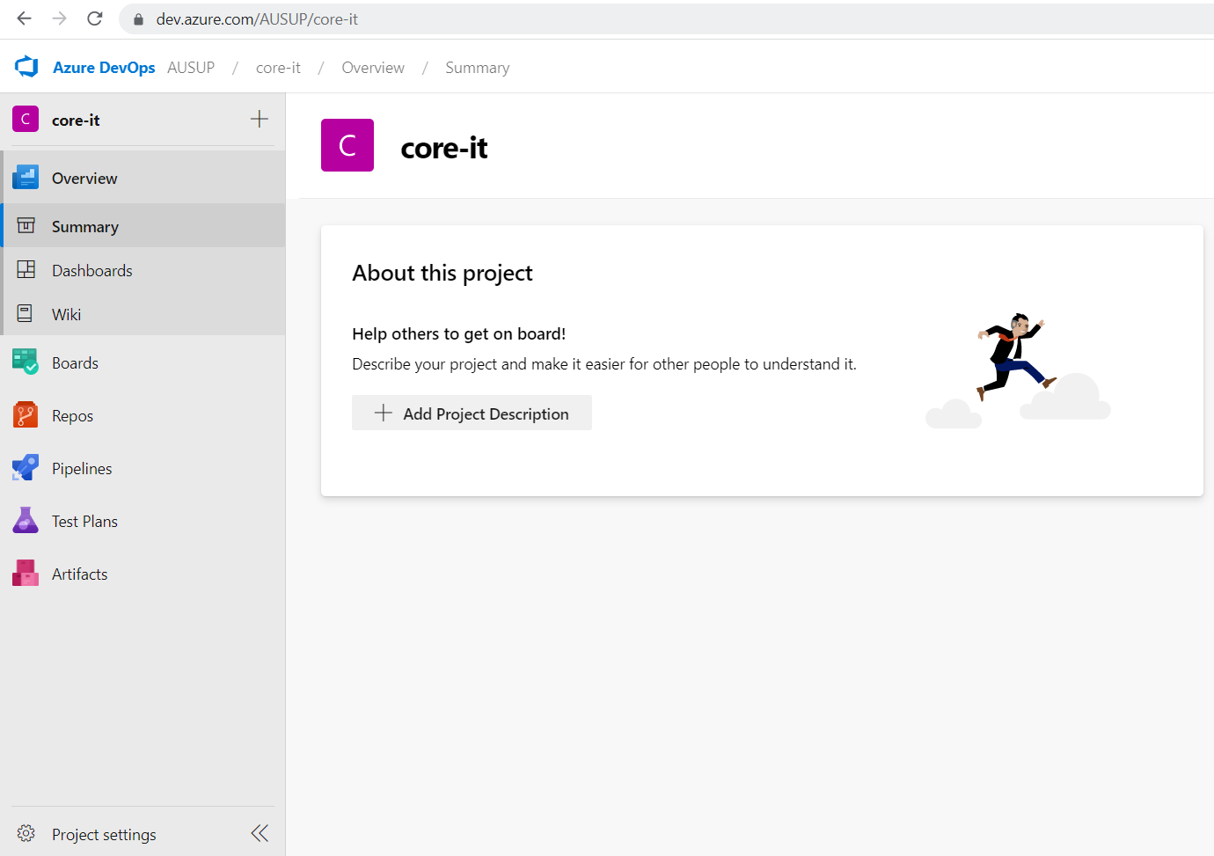
  2. Click on Boards and click on Work Items.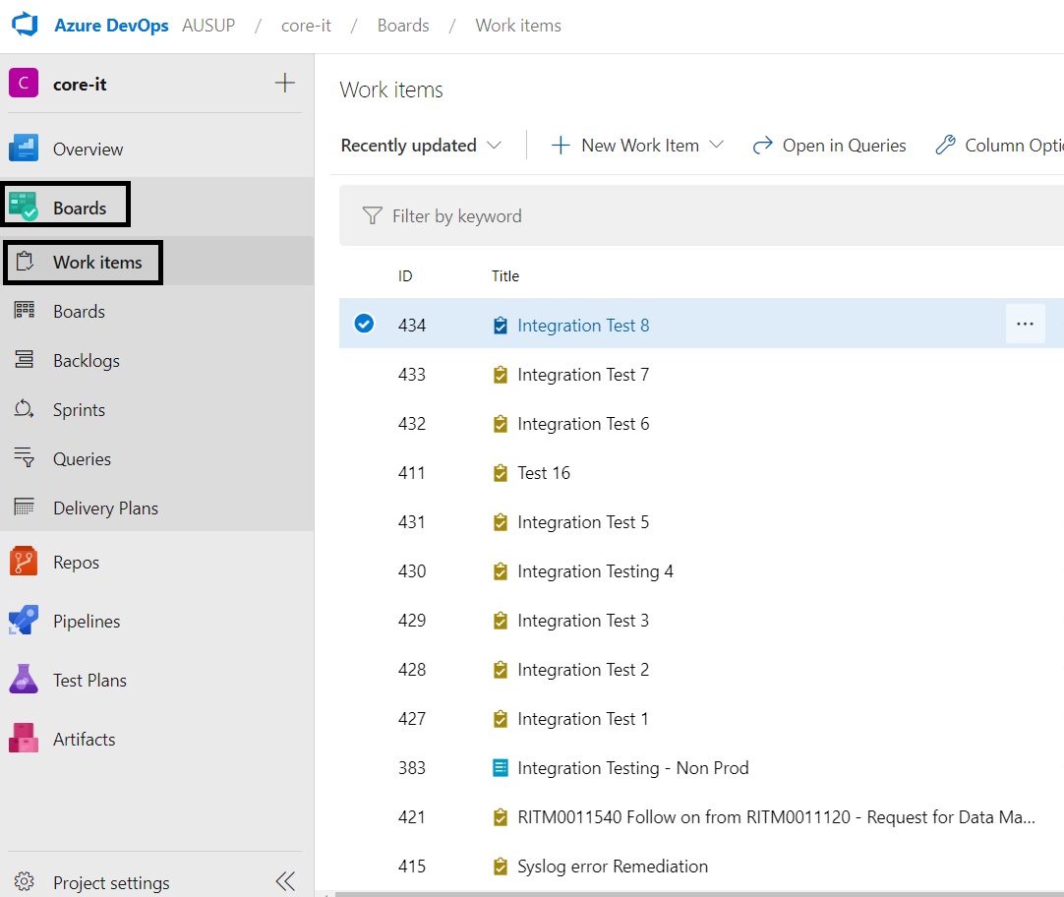
  3. Click the + New Work Item drop down and select Task.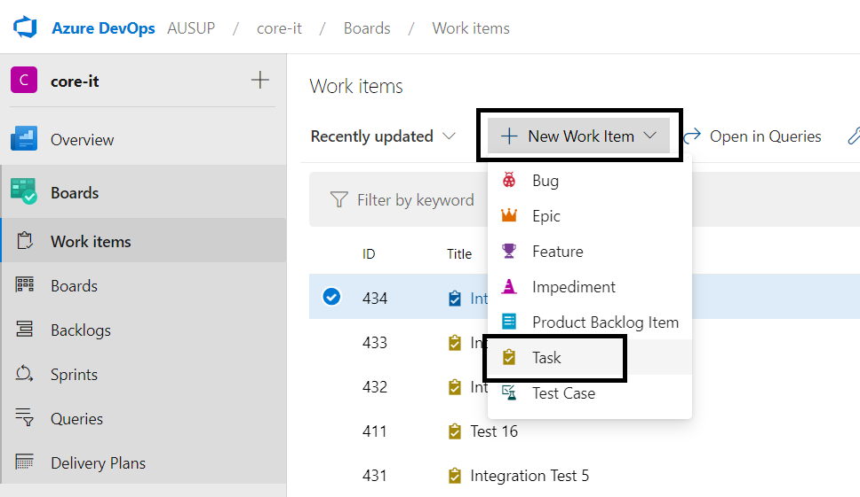
  4. Enter the Task Title and add the required tag.
  + **request: non-production** for Non-Production deployment request
  + **request: production** for Production deployment request

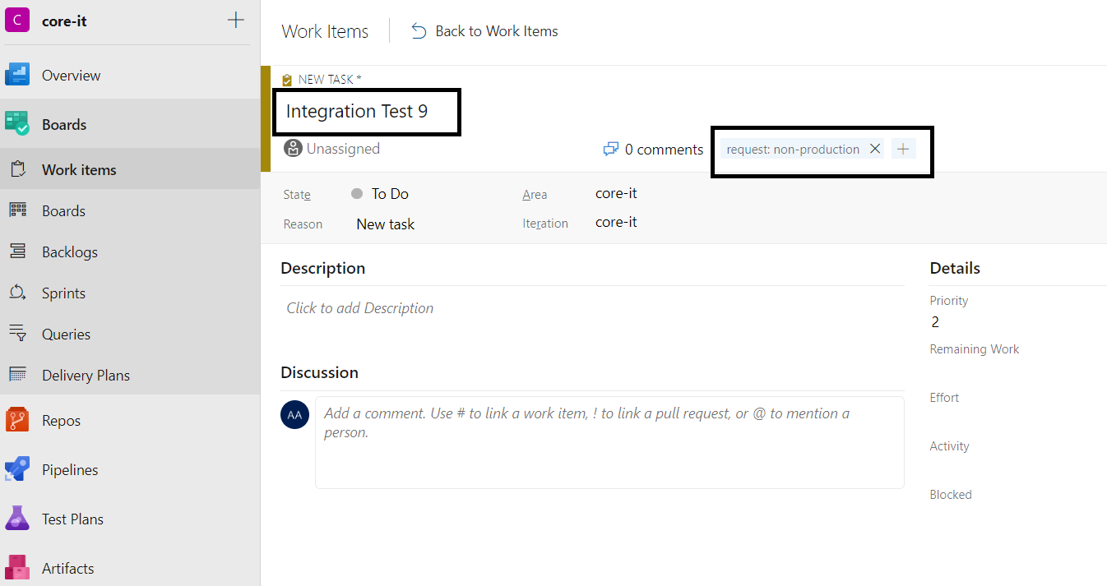

5. Upload the Input Parameter file from your local computer by going to the Attachment tab and clicking + Add Attachment button. 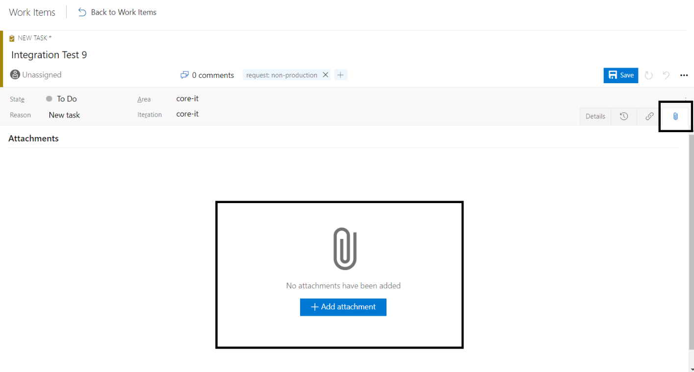

6. Make sure that the following items has values before saving:

* Area: core-it (can change depending what’s declared in the Service Hook subscription)
* Attachments: Input Parameter excel file
* Tag: request: non-production or request: production
* Task Title

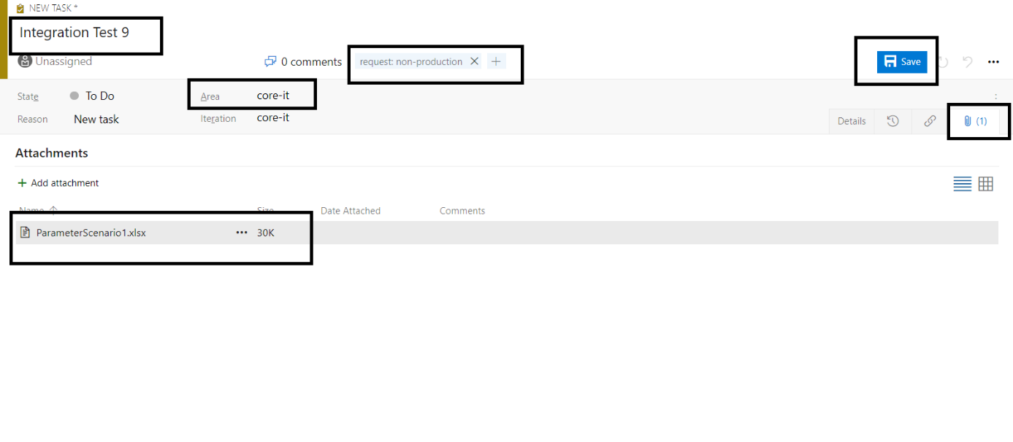

7. Linking task to a Product backlog item can also be done by following the instructions found [here](https://learn.microsoft.com/en-us/azure/devops/boards/queries/link-work-items-support-traceability?view=azure-devops&tabs=browser).

## Trigger Pipeline Stages

Trigger Pipeline has 3 stages and will perform the following task:

* Pre-Stage:
  1. Get Work Item Task Details
     + Work Item State – If work item state is To Do, Trigger Pipeline will proceed else other stages will be skipped.
     + Work Item Id – Task Number
     + Work Item Tag – To Identify whether it’s a non-production or production request.
     + Work Item Updates – If this the work item has no attachment tag, it will check if the trigger is from a work item update event and the event is triggered by uploading a work item attachment.
* Download and Publish Stage:
  1. Download the Input Parameter file from the work item task.
  2. Publish the Input Parameter file to the pipeline artifacts.
  3. Send an email if there is no attachment found in the work item task and add a no attachment tag to the work item.
  4. Add a comment on the work item task if the attachment was downloaded successfully and change its state to In Progress.
* Trigger Stage
  1. Read the Input Parameter file from the artifacts and set it into pipeline output variables.
  2. Send an email notification if failed read input parameter files from artifacts.
  3. Validate Parameters if there are lacking or mismatch parameters.
  4. Trigger the OnDemand pipeline if there are no lacking or mismatch parameters.
  5. Send and email notification if there are lacking or mismatch parameters.
  6. Add a work item comment upon successful triggering of OnDemand Pipeline.
  7. Send an email notification saying Extraction process has started.
  8. Send an email notification and add a work item comment if failed to trigger OnDemand pipeline.

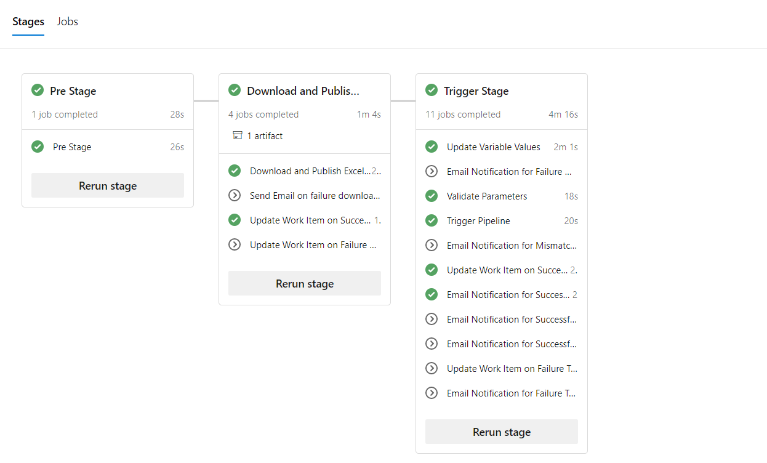

## YAML Files and Scripts

**Trigger Pipeline** - cfs-data-migration/CFS.Core.BKOF/azure-pipelines/ DMCoreTriggerPipeline.yml

**YAML Templates:**

**cfs-data-migration/CFS.Core.BKOF/templates/**

* pre-stage.yml
  + getworkitemdetails.yml
* downloadandpublish-stage.yml
  + downloadandpublish.yml
  + noattachmentemail.yml
  + updateworkitem.yml
* trigger-stage.yml
  + updatevariables.yml
  + validateparameters.yml
  + triggerpipeline.yml
  + updateworkitem.yml
  + sendemail.yml

**Scripts:**

**cfs-data-migration/CFS.Core.BKOF/scripts/**

* GetWorkItemDetails.ps1
* DownloadWorkItemFile.ps1
* UpdateWorkItem.ps1
* ExcelValuestoVariables.ps1
* ValidateParameters.ps1
* TriggerPipeline.ps1

## CR Changes

* Added different step to send email notification if runType parameter is “ETLPreprocessProduction” as this is for external process but should be in a data lake storage account. Below is a sample email notification.

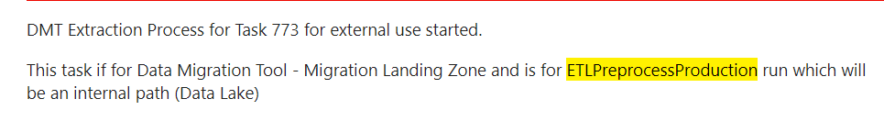

# OnDemand Pipeline

This pipeline gets triggered by Trigger Pipeline and supplied by required set of parameters. It will perform following tasks in sequential order: -

* Deploy Adhoc Domain Joined VM and mount disks based on fileSize
* Copy Script Files and Software Folder (containing PowerShell Modules, 7Zip etc) on VM
* Stripe the disks to create source (S) and destination volume (T)
* Install module on VM offline
* Deploy Destination storage account (DataLake or Sftp) based on target Data Type. This step will be carried out only in Dryrun. Pipeline will use storage account created in Dryrun for Production run. For Sftp, a SR should be created to translate firewall public ip to private ip.
* Triggers Master PowerShell Scripts and pass required set of parameters

**Bicep –** cfs-data-migration/CFS.Core.BKOF/bicep-templates/

**Pipeline** - cfs-data-migration/CFS.Core.BKOF/azure-pipelines/DMOnDemandPipeline.yml

**Scripts** - cfs-data-migration/CFS.Core.BKOF/scripts/

**Screenshot of parameters – these parameters are populated by Trigger Pipeline**

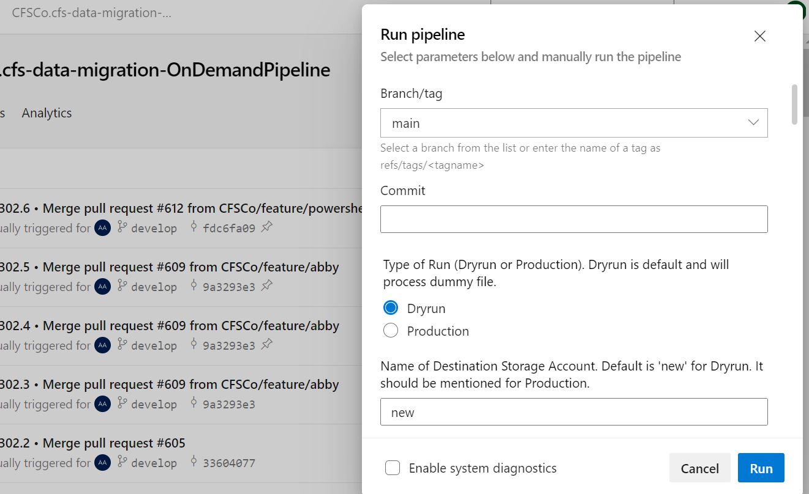

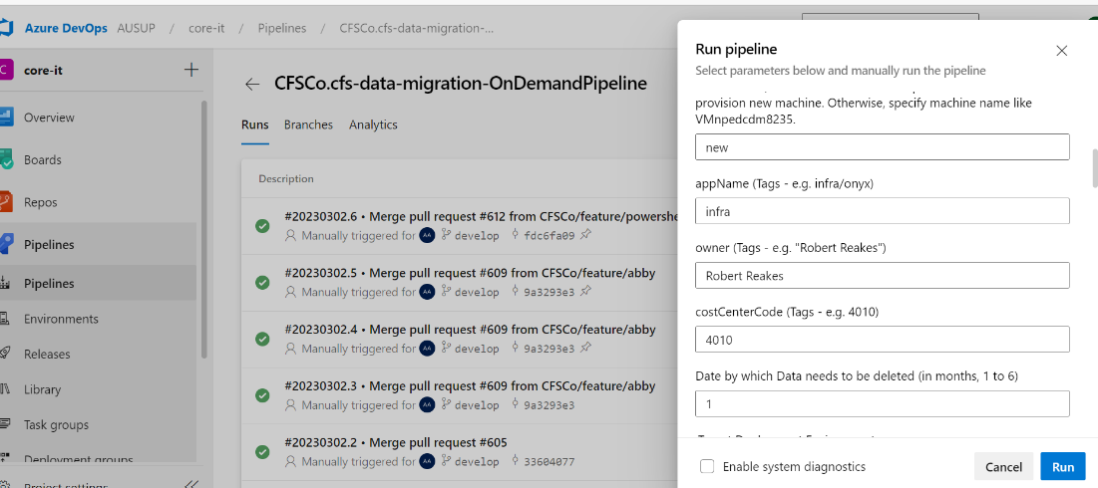

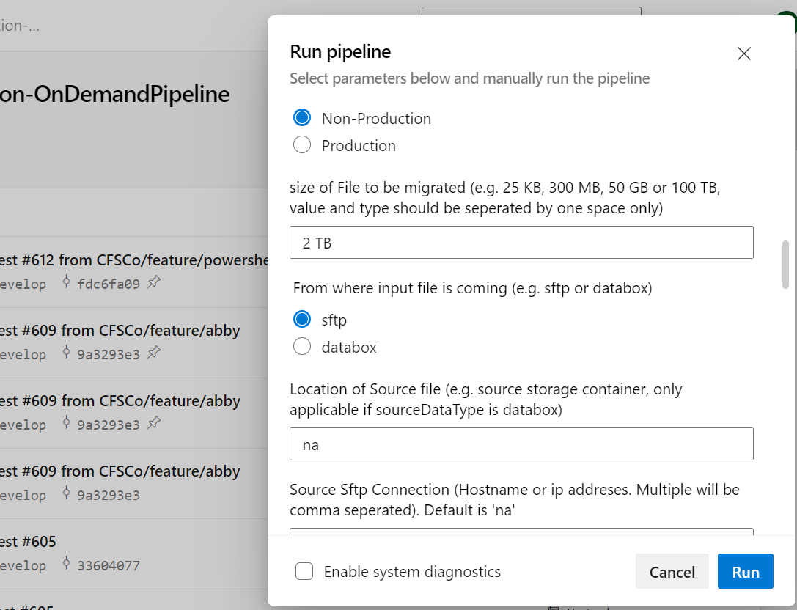

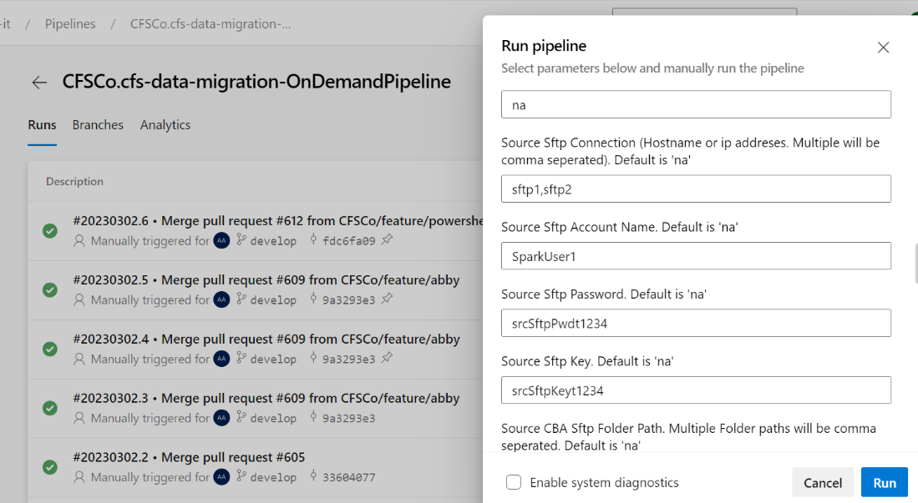

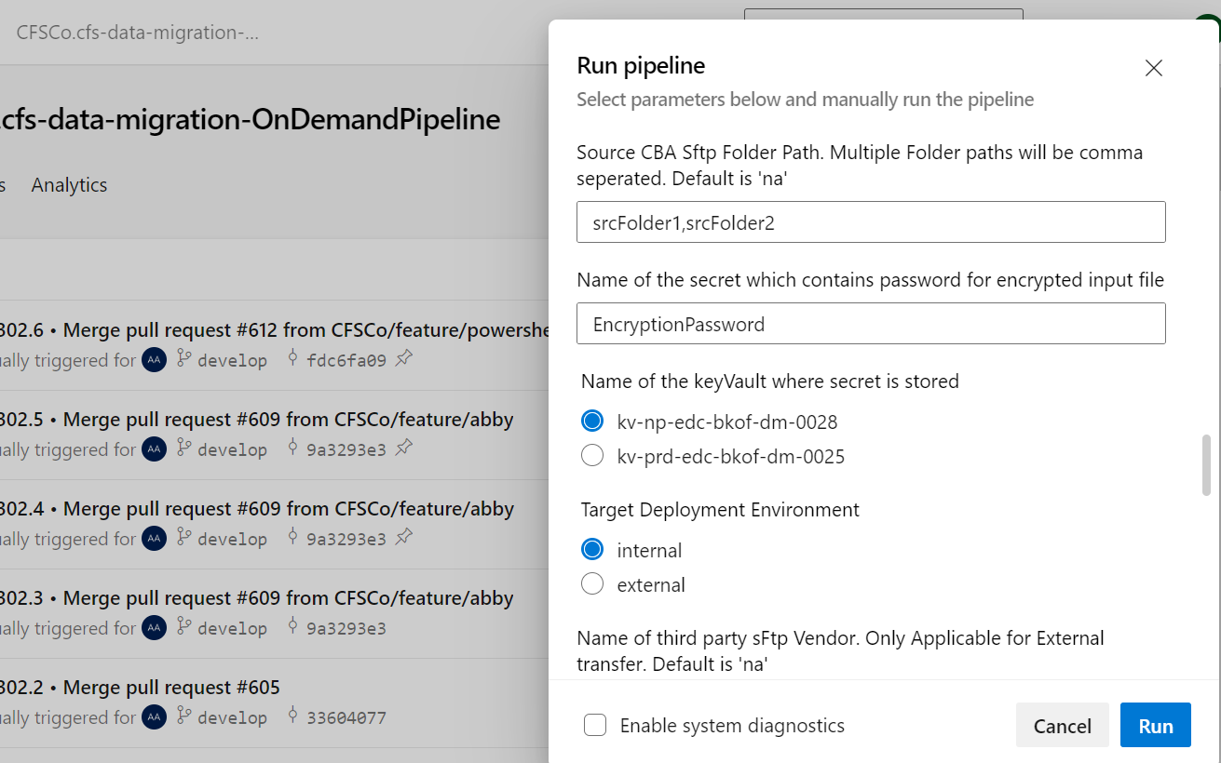

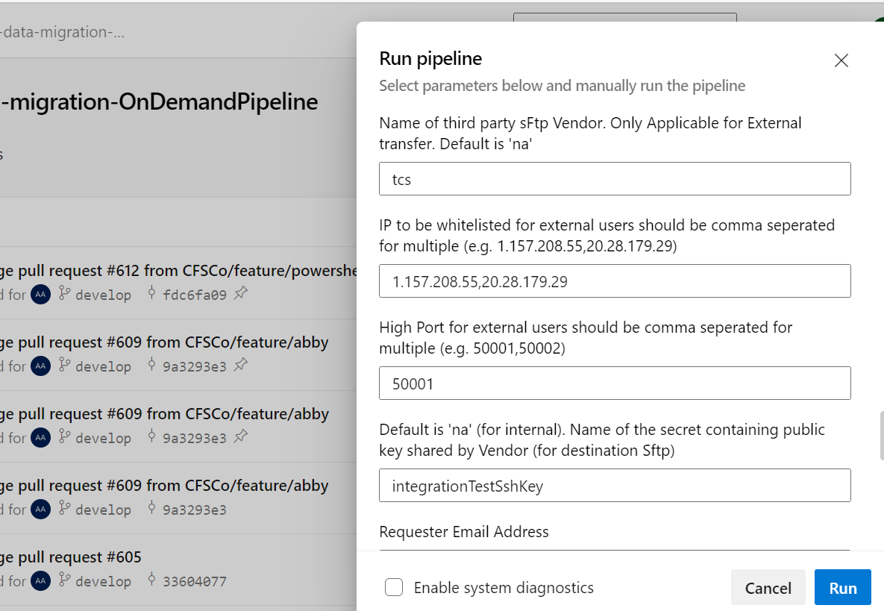

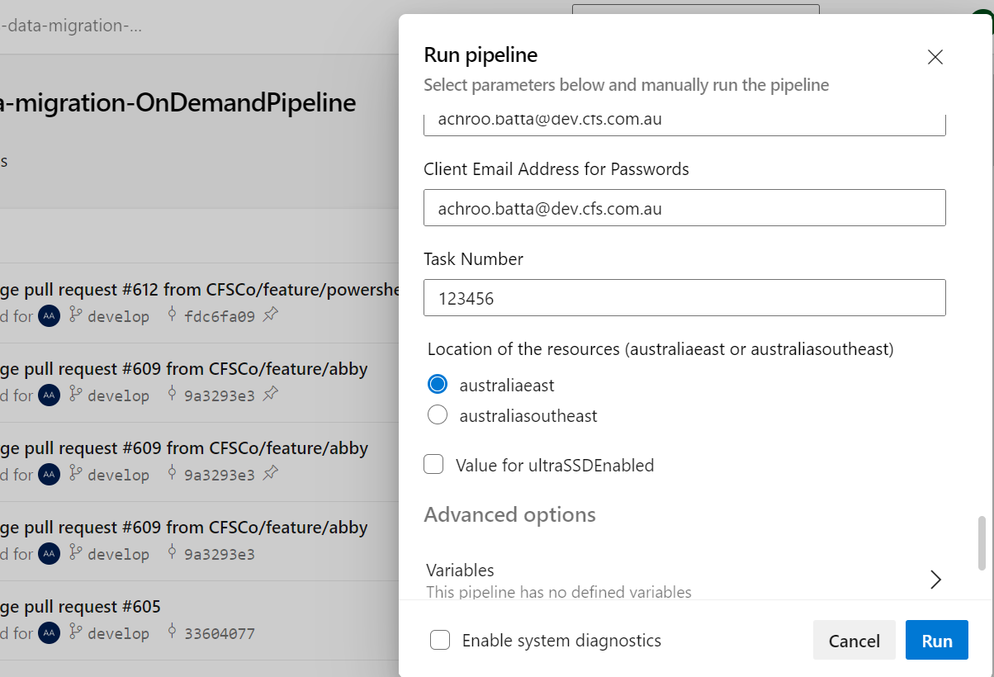

**Stages for OnDemand Pipeline**

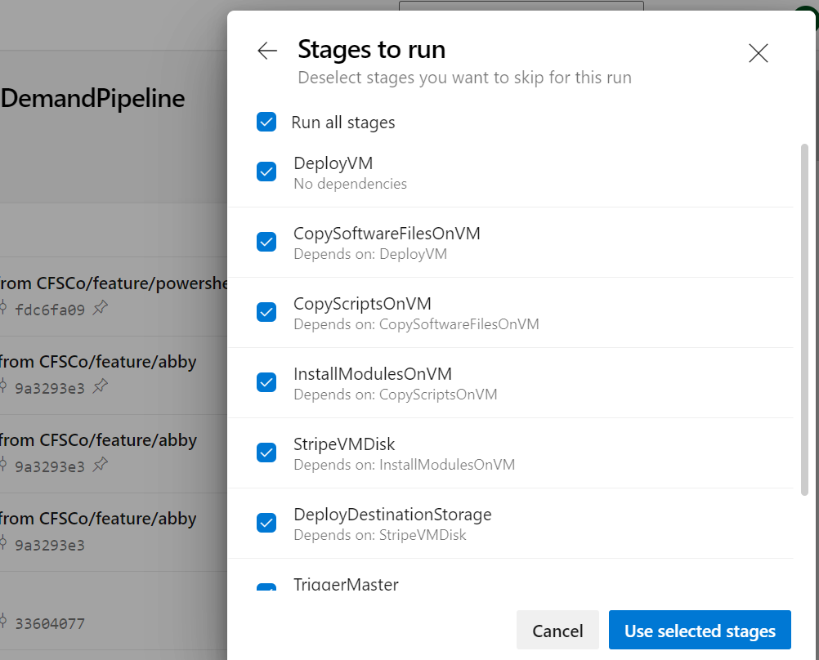

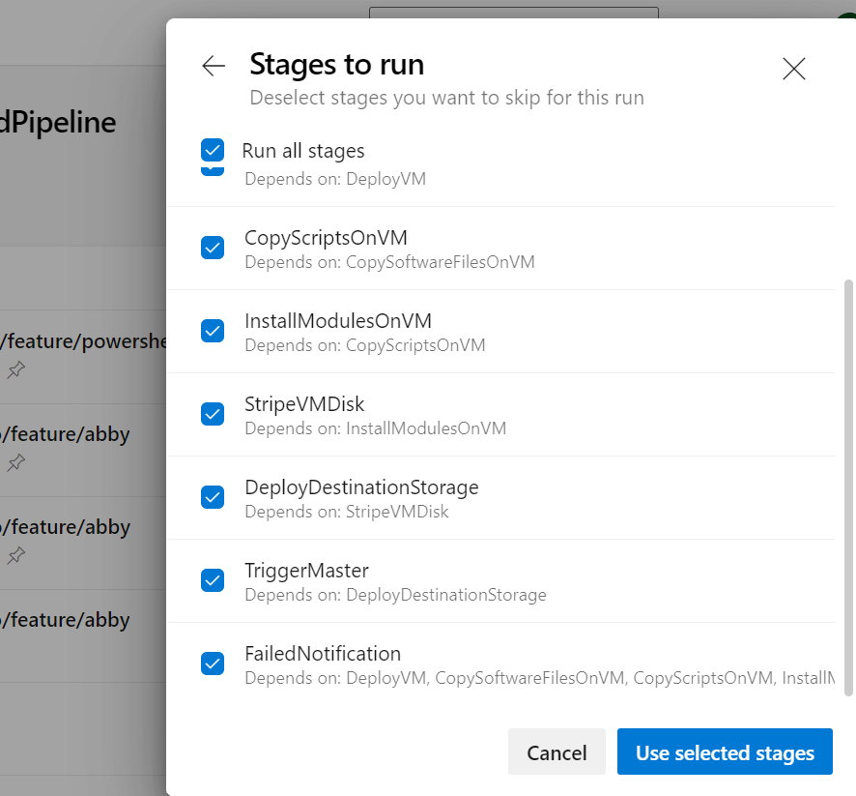

# OnDemand Pipeline - CR

This pipeline gets triggered by Trigger Pipeline and supplied by required set of parameters. It will perform following tasks in sequential order: -

* Deploy Adhoc Domain Joined VM and mount disks based on fileSize
* Copy Script Files and Software Folder (containing PowerShell Modules, 7Zip etc) on VM
* Stripe the disks to create source (S) and destination volume (T)
* Install module on VM offline
* Deploy Destination storage account (DataLake or Sftp) based on target Data Type. This step will be carried out only in ETLpreprocessDryrun. Pipeline will use storage account created in ETLpreprocessDryrun. for Production run. For Sftp, a SR should be created to translate firewall public ip to private ip.
* Triggers Master PowerShell Scripts and pass required set of parameters

**Bicep –** cfs-data-migration/CFS.Core.BKOF/bicep-templates/

**Pipeline** - cfs-data-migration/CFS.Core.BKOF/azure-pipelines/DMOnDemandPipeline.yml

**Scripts** - cfs-data-migration/CFS.Core.BKOF/scripts/

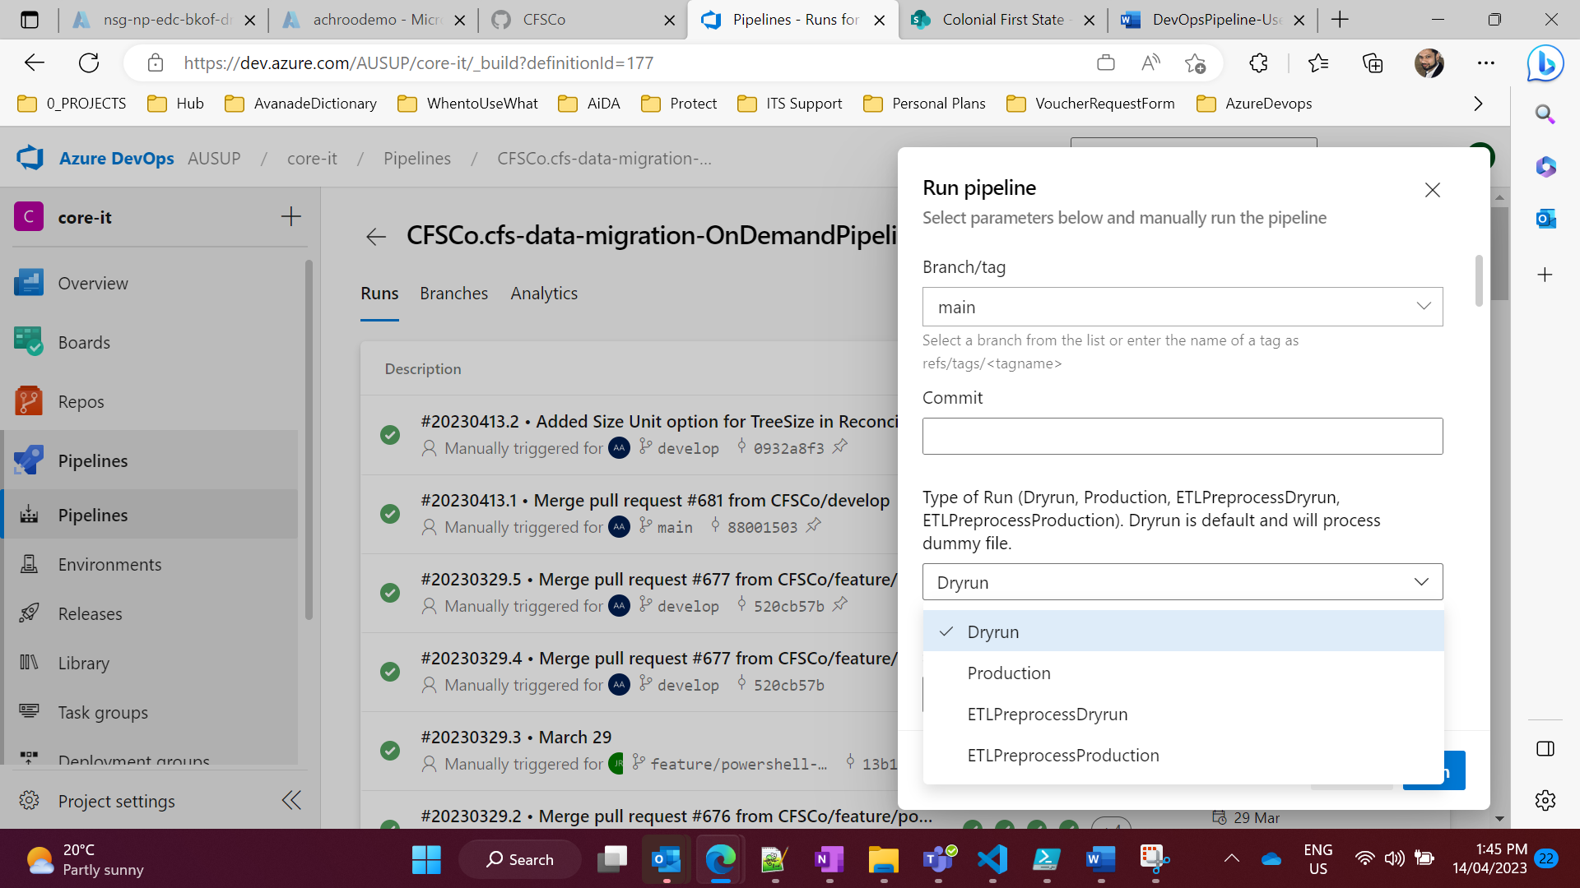

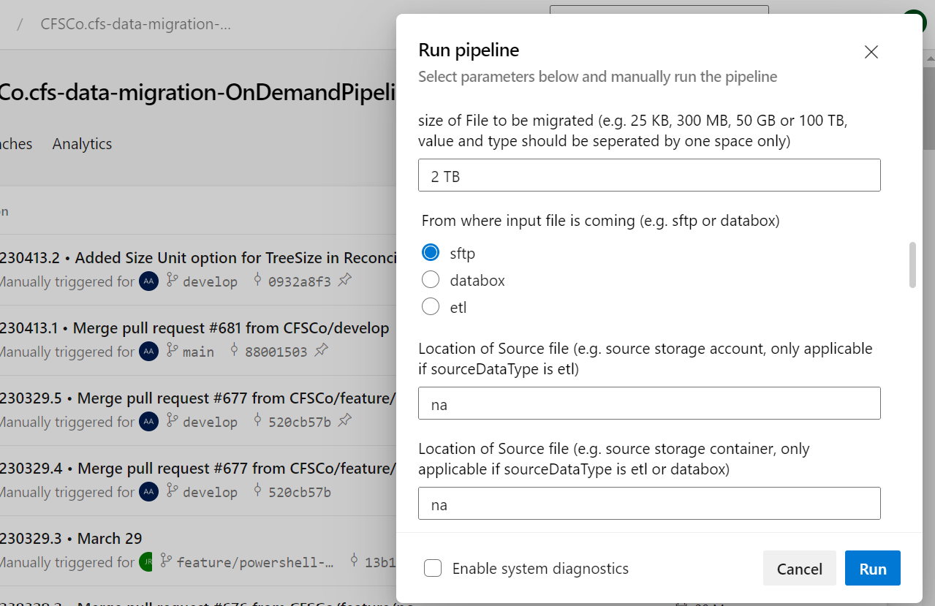

**For CR Changes**

If you need to do ETL on the file before sending it to Customer.

**ETLPreprocessDryrun**– This phase will do all the same steps which we did in pre-CR implementation. Like Allocating temporary VM, copy file/softwares to VM, installing softwares on VM and trigger master script. Additionally it will create two storage accounts one for customer will be used in Production phase and one for internally copying extracted file, on which ETL will be done by CFS. Finally this will process sample file.

**ETLPreprocessProduction** – This phase will process actual file and copy it to second storage account created in previous stage and send notification to CFS about file readiness for ETL phase.

CFS will do ETL and notify DevOps team/Application Team.

**Production –** This phase will process preprocessed file in previous phase, you also need to choose input file location coming from **ETL** by selecting radio button. This phase will process the ETL processed file and zip it and copy it to destination storage account and send notification to stakeholders.

# Master Script Powershell

PowerShell is part of DevOps, and it will trigger Master.ps1.

## Functions being run by the Master script.

|  |  |
| --- | --- |
| Prerequisites | Below are the functions being run by the Master script:  Security / Access  - Add a Personal Access Token (PAT) in Key vault and name the secret as "PAT" - Add a License Key in Key vault and name the secret as "LicenseSecretKey"  File processing (reconciliation)  - Report provided should have "Treesize" and "Hash" in the file name for the script to pick up the file  - The file should have "MD5" and "Filenames" columns and these are the required fields.  - The DMF folder should be in zip form, not the files under this folder.  Elevated access for Powershell execution - Powershell.exe should be running as Admin |
| Copy zip (password protected file) from Source storage to Disk | CBA will upload the zipped and password protected file.  Storage Account: <> Azure Key Vault: <> From the source storage account, the script will download it and copy it to S:\FromStorageAccount. |
| Read secret from Keyvault | Given the keyvault name and keyvault secret name, the script will read it. |
| Unzip and extract to another Disk | Once the secret has been acquired, the script will unzip it and copy the unzip file to T:\UnzipFile |
| As the Master.ps1 is ran, the user/s should input True or False on the Party Flag |  |
| If 3rd Party Flag is False |  |
| Copy file from Disk to Storage Location | The script will need to copy the unzipped files from T:\UnzipFile to Storage Location <> |
| If 3rd Party Flag is True |  |
| Read file from Disk Zip and encrypt the file with a secret  Write the secret in keyvault and copy encrypted file to another Disk | The script generates a password and uploads it to Azure Key Vault. Using the new password, it will zip the file and save it to T:\EncryptedZipFile.  Also, the script will automatically create a secret name as it uploads on the key vault. |
| Copy file from Disk to SFTP Storage location | This script will copy the zipped file from T:\EncryptedZipFile to SFTP Storage account <> |
| Create logs | Included as a function on the Master.ps1. This will log the message progress in work item at DevOps. |
| Limitations |  |
| Installation | Unable to check if the installation has a defect. |
| Zip files | - If there are files other than zip files, the unzip7zUsingKeyvaultSecret.ps1 will fail. - Cannot process 2 zip files with different passwords. - Compression level should be "fastest" the same as the source zip file. |

## Scripts definition and needed parameters.

All PowerShell scripts are stored in CFS Github.

The below table has been updated and includes all the changes completed during CR build of solution.

|  |  |  |
| --- | --- | --- |
| **PowerShell Scripts** | **Script Usage** | **Parameters Needed** |
| Master.ps1 | This will call all the PowerShell scripts, and this will be used by DevOps | #Dynamic Parameters  [string]$commRG  [string]$vmRG  [string]$keyVaultNameforSecret  [string]$secretName  [String]$destStorageAccount  [String]$destContainerName  [string]$deployEnvironment  [string]$targetDataType  [string]$sourceDatatype  [string]$sourceLocation  [string]$buildId  [string]$sftpUsername  [string]$sourceStorageAccountfromPipeline    #SFTP Connection  [string]$srcSftpCtn  [string]$srcSftpAcctNm  [string]$srcSftpPass  [string]$srcSftpKey  [string]$CBASFTPSourcePath    #DevOps Parameters  [int]$taskNumber  [string]$resourceLocation  [string]$vmName  [string]$diagStorageAccount  [string]$emailAddress  [string]$clientEmailAddress  [string]$runType  [string]$appName  [string]$etlDestStorageAccountName  #Azure connection  [string]$subId  [string]$subTenantId |
| copyfromStoragetoDisk.ps1 | Download of files from Storage to local disk, or drive S:\ FromStorageAccount  - *This script will be activated if there is a 7zip installed already when downloading files from the source disk Databox.* | [string]$sourceStorageAccount  [string]$localTargetDirectory  [string]$sourceLocation [string]$subId  [string]$subTenantId |
| copyFilefromLocaltoStorage.ps1 | If flag is False on Master.ps1 Files after unzipping and reconciliation, will be uploaded to Storage account.  *- This script will be called if there are no mismatches in reconcilliationReport.ps1 and destination are equal to internal.* | [string]$commRG  [string]$destStorageAccount  [string]$destContainerName  [string]$unzipPath  [string]$subId  [string]$subTenantId |
| zipFileUsing7z.ps1 | If the flag is true this script will call generatePassword.ps1, zip the file using 7zip with newly generated password and save it on a new path.  *- This script will be called if there are no mismatches in reconcilliationReport.ps1 and destination is not equal to internal.* | [string]$keyVaultNameforSecret  [string]$localTargetDirectory  [string]$unzipPath  [string]$zipPath  [string]$sftpUsername  [string]$subId  [string]$subTenantId |
| copyFilefromDisktoSFTP.ps1 | Copy the zipped file from Disk (T:\EncryptedZipFile) to SFTP (Storage account). This is the next action after zipFileUsing7z.ps1  *- This script is called after zipFileUsing7z.ps1* | [string]$commRG  [string]$destStorageAccount  [string]$zipPath  [string]$destContainerName  [string]$subId  [string]$subTenantId |
| CopyFilefromSFTPtoDisk.ps1 | Copy the zipped file from CBA SFTP to Disk. Whereas Disk is the Landing Zone.  *- This script will be activated if there is a 7zip installed already when downloading files from the source disk SFTP.* | [string]$commRG  [string]$localTargetDirectory  [string]$keyVaultNameforSecret  [int]$taskNumber  [string]$buildId  [string]$sourceStorageAccount  [string]$srcSftpCtn  [string]$srcSftpAcctNm  [string]$srcSftpPass  [string]$srcSftpKey  [string]$CBASFTPSourcePath  [string]$subId  [string]$subTenantId |
| UnzipusingKeyVaultSecret.ps1 | Script to unzip the files that have been downloaded from the Storage account. On this script, calling the secret from the Key Vault is also included, the extracted file will be saved on T:\UnzipFile. | [string]$keyVaultNameforSecret  [string]$secretName  [string]$localzippath  [string]$unzipPath  [string]$subId  [string]$subTenantId |
| generatePassword.ps1 | Script to generate random password and upload it to Azure Key Vault  - *This script is being called by zipFileUsing7z.ps1* | [string]$keyVaultNameforSecret  [string]$sftpUsername  [string]$subId  [string]$subTenantId |
| PowerShell-readme.txt | File containing descriptions, script names, usages and variables used of each ps1 modules | No parameters required |
| Install7zip.ps1 | Installs 7zip and Treesize. The installation will be done and located at the C:\Users\<name of the user>\softwares  *- This script can detect if the software is already installed or not within the VM.* | [string]$keyVaultNameforSecret  [string]$subId  [string]$subTenantId |
| LoggingDevOps.ps1 | Add work item comment in DevOps.  *- This script is called for every subscript in Master.ps1* | $WorkItemComment  [int]$taskNumber  [string]$keyVaultNameforSecret  [string]$subId  [string]$subTenantId |
| ReconciliationReport.ps1 | This will help verify the files if the count of files extracted from Source to Target have a success migration or missed some files during migration.  *-This script is called after UnzipusingKeyVaultSecret.ps1* | [string]$unzipPath  [string]$localTargetDirectory |
| TriggerHousekeeping.ps1 | This script will trigger the Housekeeping Pipeline to start the cleanup of resources (VMs, and other items within the resources) in Azure by passing required parameters from TriggerHousekeeping.ps1 to Housekeeping Pipeline.  *- This script is called after copyFilefromLocaltoStorage.ps1 or copyFilefromDisktoSFTP.ps1* | [int]$taskNumber  [string]$deployEnvironment  [string]$vmName  [string]$vmRG  [string]$diagStorageAccount  [string]$resourceLocation  [string]$emailAddress  [string]$commRG  [string]$targetDataType  [string]$destStorageAccount  [string]$destContainerName  [String]$keyVaultNameforSecret  [String]$clientEmailAddress  [String]$sftpUsername  [String]$runType  [String]$manualVerificationEmail  [String]$tvtresult  [String]$unzipPath  [string]$appName  [string]$subId  [string]$subTenantId  [string]$realTimeMonitoringEmail  [string]$threatLogs  [string]$stgMisMatch  [string]$sourceDatatype  [string]$etlDestStorageAccountName |

## Migration Flow

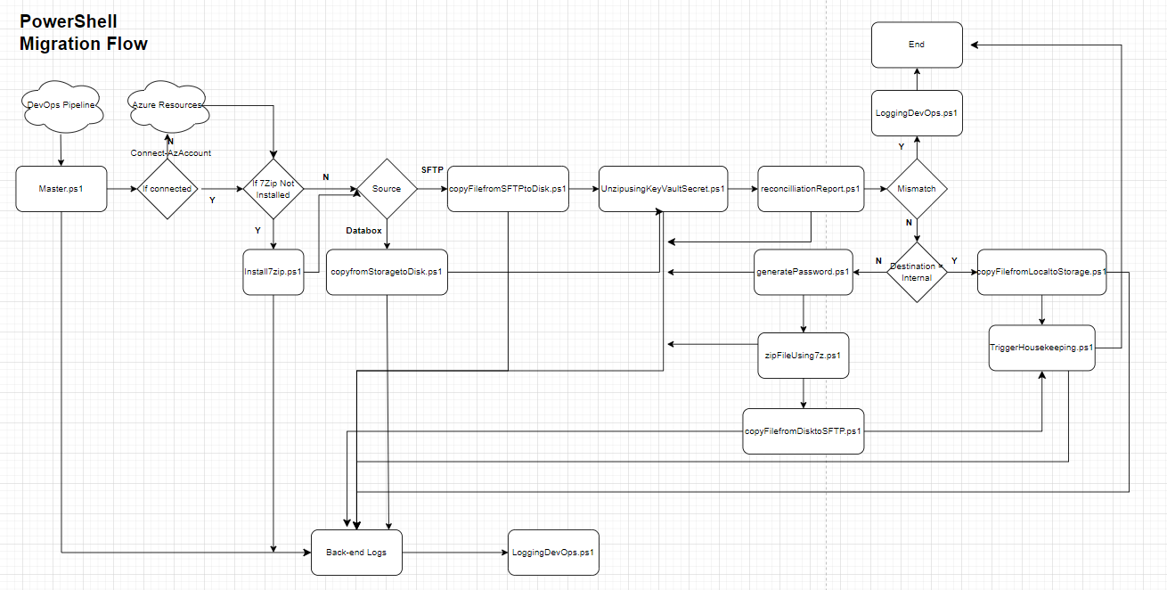

## Script Monitoring

Log to spined Virtual Machine

Check the progress of each script by looking at backend logging on this path ***C:\Users\ADM-AD-DMT-***  ***CFS\scripts***

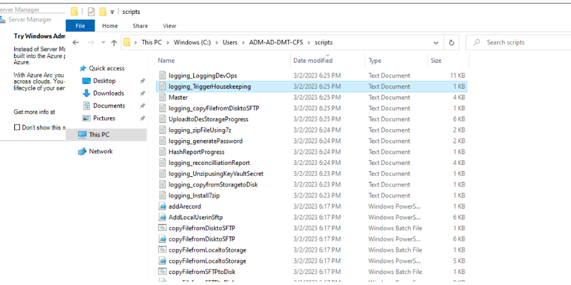

## Definition of terms

This section will stand as an indicator of the words to clarify the definition.   
Added as of **Feb 13, 2023.**  
  
**Github** – Github is a platform that can store scripts and other lines of code. It can host repositories and pull requests so a developer can collaborate with other developers for a project.  
  
**Bicep** – Is a language used within Microsoft Azure whose main function is to use syntax to deploy Azure resources.  
  
**Zip file** – A file that consists of multiple encrypted files.  
  
**Unzip** – Is a process where a Zip file is extracted to a specified folder and inside that folder, all the contents within the Zip file can now be viewed as it is now decrypted.   
  
**Encryption** – A method of security that installs the idea of using a process into a code to avoid unauthorized access.  
  
**Hash** – an algorithm that calculates a fixed-size bit string value from a file.  
  
**VM** – Stands for Virtual Machine. Uses software instead of a physical computer to run programs and apps.  
  
**DevOps** – Derived from “Development” and “Operations”. Is a practice or department of IT field that designs the practice and tools needed for automation to ensure faster delivery rate of development.  
  
**Azure DevOps** – Is an app within Microsoft Azure that helps the developer by offering tools to use.

**Personal Access Token** – It contains your security credentials for Azure DevOps. It is an alternative to using passwords for authentication to GitHub when using the GitHub API or the command line.   
  
**Script** – Is a sequence of instructions that is interpreted in a software compiler  
  
**Logs** – Is a text that shows the status of a workspace or progress of the project.

**TreeSize** – Is a powerful and flexible hard disk space manager for Windows. Graphical analyses provide a quick visualization of disk space usage

**7-Zip** – Is a file archiver with a high compression ratio.

**Azure Key Vault** – Is a cloud service for securely storing and accessing secrets. A secret is anything that you want to tightly control access to, such as API keys, password, certificates, or cryptographic keys.

**PowerShell** – Is an automated task-based command-line shell and associated scripting language created by Microsoft.

**Landing zone** – Is comprised of building blocks that cover foundational elements of cloud deployments. The target area of migration process for downloading the files.

**Parameter** – Is a special kind of variable used in a function to refer to one of the pieces of data provided as input to the function.

**Migration –** Refers to a process which transfer data processing or information systems to different technology.

## CR Changes

* New script for checking if Real Time Monitoring is enabled in the VM deployed. This script is the first one to be called when OnDemand pipeline triggers the Master.ps1 script.
  + Script File Name: CheckRealTimeMonitoring.ps1
  + Script Description: This script will execute the ff command:
    - **Update-MpSignature** - used to update the antimalware definitions in Windows Defender or Microsoft Security Essentials.
    - **Get-MpComputerStatus** - used to retrieve the status of the antimalware protection on a computer running Windows Defender or Microsoft Security Essentials. This command will check the ff properties:
      * **AntivirusEnabled**
      * **AntispywareEnabled**
      * **RealTimeProtectionEnabled**
* Modified Master.ps1 script to add process flow if sourceDataType parameter is “etl”.
  + ETL Process flow:
    - Validation if storage account and container is valid and trigger Housekeeping pipeline to send an email notification if validation failed.
    - Copy data to local disk from source.
    - Zip Data with encryption
    - Copy Data from local disk to destination storage account.
* New Script to Check Threat Logs.
  + Script File Name: CheckThreatReports.ps1
  + Script Description: This script will list the threats detected by Windows Defender which will be sent as an email notification by Housekeeping Pipeline.

# HouseKeeping Pipeline

This pipeline will be triggered by the Master.ps1 script and and has the ff stages:

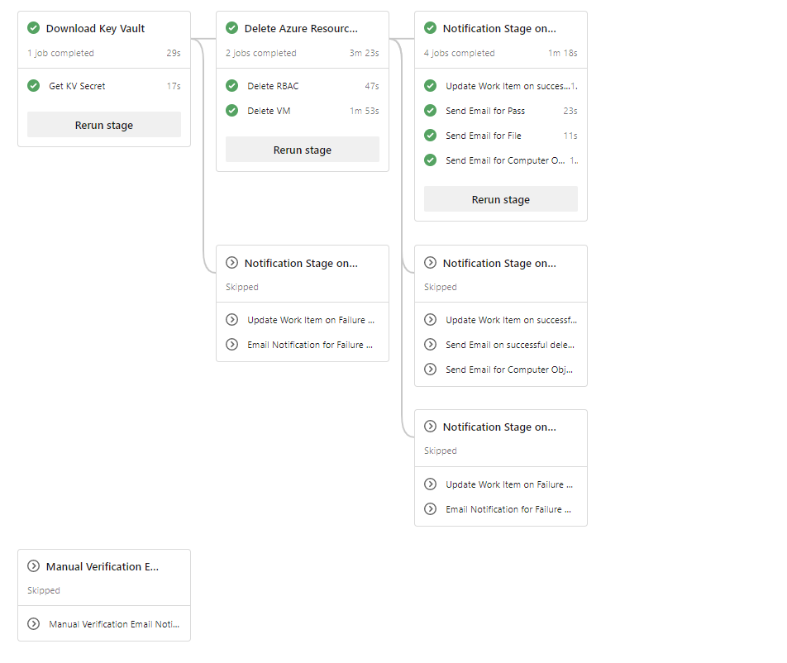

Parameters will be populated by the Master script:

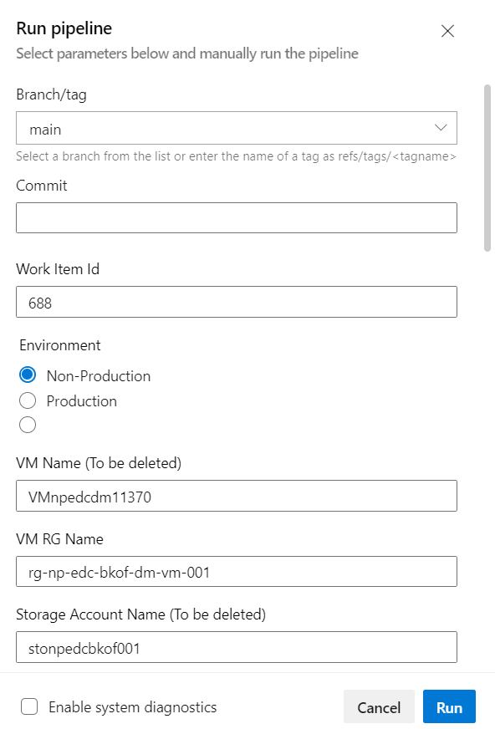

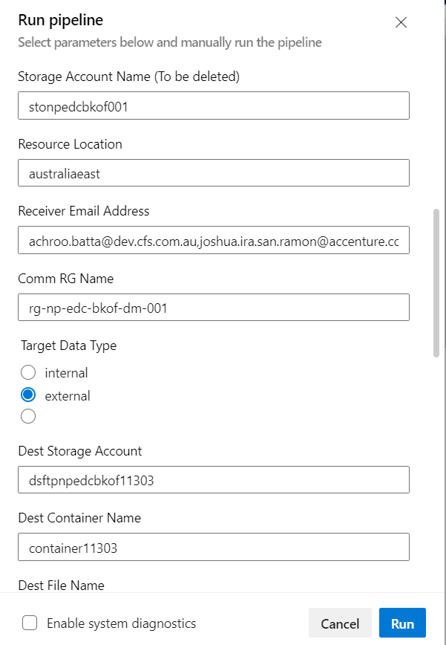

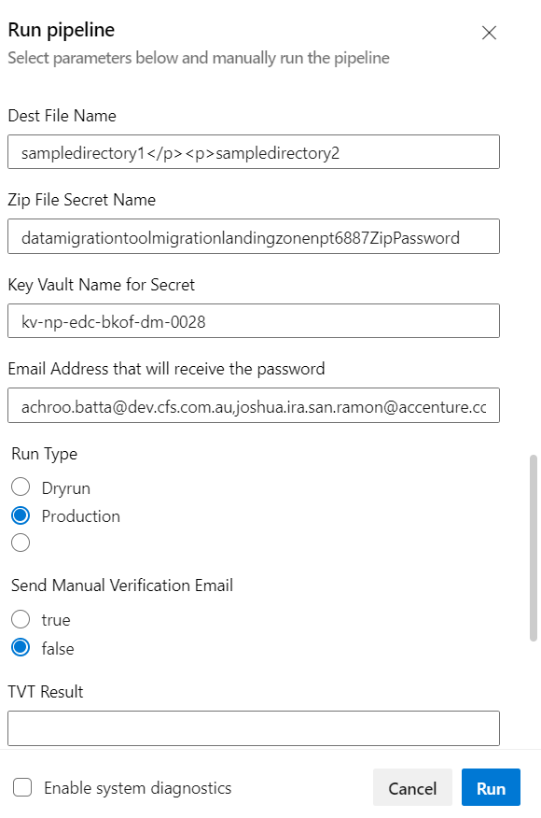

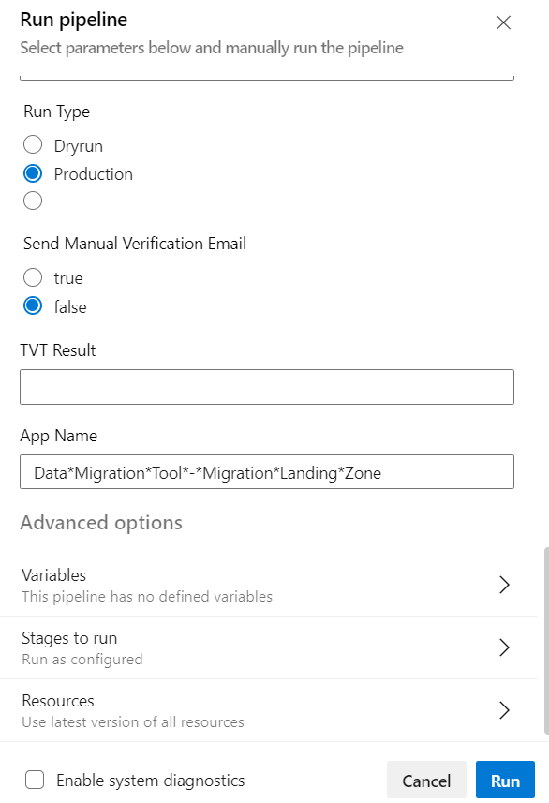

## Housekeeping Pipeline Stages

* Download Key Vault Secret Stage – this will only run if targetDataType parameter is external
  1. Run script on the domain join VM that will get the key vault secret value from the Key Vault using the following parameter.
* Delete Azure Resources Stage

1. Clear Roles for system assigned identity of VM
2. Delete VM and associated disks

* Notification Stage Internal – this will only run if targetDataType parameter is internal and deletion is successful
  1. Update work item state to Done and add a work item comment
  2. Send an email notification saying extraction process is completed. It will also contain the file details information.
  3. Send an email notification to CFS AD team with subject "Computer Object deletion in AD".
* Notification Stage External – this will only run if targetDataType parameter is external and deletion is successful
  1. Update work item state to Done and add a work item comment
  2. Send an email notification saying extraction process is completed. It will also contain the zip file details information.
  3. Send a separate email notification containing the file password
  4. Send an email notification to CFS AD team with subject "Computer Object deletion in AD".
* Notification Stage - Failure to get Key Vault Secret value
  1. Send an email notification that Housekeeping pipeline failed.
* Notification Stage - Failure to delete Azure Resources
  1. Send an email notification that Housekeeping pipeline failed.
* Manual Verification Email:
  1. Send an email notification for Reconciliation script results.

## YAML Files and Scripts

**Housekeeping Pipeline** - cfs-data-migration/CFS.Core.BKOF/azure-pipelines/ DMCoreHouseKeepingPipeline.yml

**YAML Templates:**

**cfs-data-migration/CFS.Core.BKOF/templates/**

* download-key-vault-secret-stage.yml
  + getkvsecret.yml
* deleteazureresources-stage.yml
  + deleterbac.yml
  + deletevm.yml
* notification-stage-internal.yml
  + updateworkitem.yml
  + sendemail.yml
* notification-stage-external.yml
  + updateworkitem.yml
  + sendemail.yml
* notification-stage.yml
  + updateworkitem.yml
  + sendemail.yml
* manual-verification-stage.yml
  + sendemail.yml

**Scripts:**

**cfs-data-migration/CFS.Core.BKOF/scripts/**

* GetKeyVaultSecret.ps1
* UpdateWorkItem.ps1

## CR Changes

* Added new pipeline stages:
  1. Real Time Monitoring – This will send an email notification if Real Time Monitoring is not enabled in the deployed VM
  2. Threats Report Email – This will send an email notification containing the list of threats detected. No Threats found will be in the email content if there are no threats detected.
  3. Storage Account Mismatch - This will send an email notification if the storage account and container provided in the input parameter file is mismatch or not existing.
* Multiple Notification Stage dependent of run type and source data type

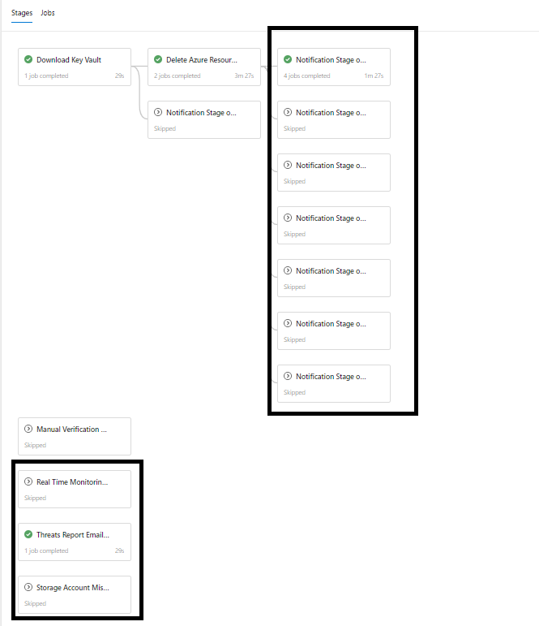

# End-to-End Testing

For end-to-end testing, the initial task for user is to prepare the input parameter file to be used for the execution. Once this is created, a work item task can be created in DevOps with this file as an attachment which will automatically trigger the Trigger Pipeline.

## Input Parameter File

Input Parameter File contains the parameter values to be used during the execution of the pipeline. This serves as the input point for the pipeline. It is in .xlsx format and will be attached in Azure Board Task to automatically initiate the execution of pipeline. Values specified in this file will determine the different scenario that will be triggered for testing.

To create input parameter file:

* 1. Download input parameter file template from below location:

[Migration Framework template_v5_finalised-CR.xlsx](https://avanade.sharepoint.com/:x:/r/sites/ColonialFirstState-CoreIT-Delivery/Shared%20Documents/Core%20IT%20-%20Delivery/NAS%20Data%20Migration/Delivery%20Documents/Minimum%20Viable%20Service%20Operating%20Model/Migration%20Framework%20template_v5_finalised-CR.xlsx?d=w5121090f5e3d4fc494ccf0297c946304&csf=1&web=1&e=BfKge3)

* 1. Update the values in column E (Values) of the parameter file template based on the testing scenario that you need to complete then save the file on your local machine. These are the values that will be consumed for the variables defined in the pipelines upon execution.

To be guided on filling up the value, please see below table. This shows list of variables used in pipelines and describes what and how values can be specified depending on the testing requirements.

*Key Points:*

* If source is sftp, source connection details should be specified.
* If source is databox, source location should be specified.
* If destination (targetDataType) is internal, Data Lake Gen 2 storage will be created.
* If destination (targetDataType) is external, SFTP storage will be created.
* If run type is Dryrun, both VM and destination storage will be created.
* If run type is Production, only VM will be created. Creation of destination storage will be skipped.

*Note!*

*Column E mentioned in Input options column corresponds to column E (Values) of the parameter file template.*

|  |  |  |  |
| --- | --- | --- | --- |
| **Field Name** | **VariableName in Pipeline** | **Input options** | **Description** |
| Type of Run | runType | Choose the appropriate value in column E from DropDown | Dryrun will prepare infrastructure like VM, disks and destination storage account and will transfer dummy files to it. Production run is processing actual file (new VM/disks will still be provisioned, new storage accounts will not be provisioned) |
| Destination Storage Account | destStorageAccount | **If runType is equal to Dryrun,** then enter value **'new**' in Column E. **ELSE**, **If runType is equal to Production**, Please enter name of StorageAccount created/sent during Dryrun in Column E | Please ensure destination storage account exists. it should be new for Dryrun and have value for Production. new means new storage account will be created, only possible for Dryrun scenario. |
| Application Name | appName | Please enter name of Application in Column E | This name will be used for tagging resources for billing purposes and also will be used in Emails. This name should not be longer than 57 characters. Special characters allowed are Hyphens(-), space and underscore(_) |
| owner | owner | Please enter name of Owner in Column E | The Business application owner, for the app requireing data transfer |
| Cost Center, code and contact | costCenterCode | Please enter Cost Center in Column E | The app requiring data transfer Cost Centre Code to be added here |
| Warranty period (number of Month) | warrantyPeriod | Please enter number value in Column E | How many months should the data be retained for on the storage account? integer only. represents data deletion. A grace period of 15 days will be added in this number, while provisioning. |
| Migration environment | deployEnvironment | Choose the appropriate value in column E from DropDown | Non-Production will deploy infra in non-prod backoffice subscription and Production will deploy infra in production backoffice subscription. |
| Size of data | fileSize | Please enter approx size of the file in Column E. Number and type should be separated by only one space. No leading/trailing spaces. | it should contain number sepeated by size. e.g. 2 KB, 100 MB, 100 GB or 2 TB. This field is an important one, as it will decide type of machine being used for extraction and also attach number of disks based on size. |
| Source data type | sourceDataType | Choose the appropriate value in column E from DropDown | This value signifies from where input file be picked for Extraction. sftp represents source zip file is in CBA SFTP location. databox represents source zip file is in predefined sourcestorageaccount' container(s). etl represents, after ETL processing source extracted file is in below mentioned source storage account and sourcedatalocation. It should be only selected if runType is production and after ETL Changes done by CFS team. otherwise, it would be sftp or databox. |
| Source Storage Account | sourceStorageAccountFromPipeline | **If sourceDataType is etl,** name of storage account will come **in column E, else it is na** | This value is populated after ETL processing is complete. Name of the storage account in which ETL processed file(s) is(are) present. |
| Source data location | sourceLocation | **if SourceDataType is databox or etl,** Please provide container name(s) in Column E.Multiple containers should be comma seperated. **ELSE If SourceDataType is 'sftp'** then please enter value as **na** in Column E | if more than one container name needs to be provided, it should be comma seperated. |
| Sftp Connection | srcSftpCtn | **If SourceDataType is sftp**, please enter ip address of CBA Sftp server in Column E. Multiple IP Addresses should be comma seperated. **ELSE**, **if SourceDataType is databox/etl**, then Please enter value as  **na** in Column E | value will be provided by CBA/CFS and it will be passed as a parameter. This is the IP address that CBA DMF SFTP server is located at, it will always be below IP's. Both can be used (comma seperated). 192.168.255.32 192.168.255.97 |
| Sftp Account Name | srcSftpAcctNm | **if SourceDataType is sftp**, Please enter username of Sftp Connection in Column E. **ELSE, if SourceDataType is databox/etl**, Please enter value as **na** in Column E | Each Appname will have a unique username for Non Prod and Prod. The App Username will be pre-created and available in a seperate spreadsheet TBD |
| Sftp Password | srcSftpPass | **if SourceDataType is sftp**, Please enter keyVault secretname, where password for sftp connection is stored in Column E. **ELSE, if SourceDataType is databox/etl**, then Please enter value as **na** in Column E | Each AppName will have a unique password for Non Prod and Prod. The App Passwords will be pre-created and the Avanade team will upload the secrets to Key Vault.   The key vault secret will be used as password repository.  Avanade/CFS person needs to create a secret in keyvault with the value of password. the name of secret should be srcSftpPwd + t + taskNumber. |
| Sftp Key | srcSftpKey | **if SourceDataType is sftp**, Please enter keyVault secretname which stores private key for sftp in Column E. **ELSE, if SourceDataType is databox/etl**, then Please enter value as **na** in Column E | Each App will have a unique key pair for Non prod and Prod respectively. This key will be pre-created and the Avanade team will upload the secrets to the Key Vault. The private key should be added here to allow decryption of SFTP traffic between DMF CBA environment  Avanade/CFS person needs to create a secret in keyvault with the value of private key. the name of secret should be srcSftpKey + t + taskNumber. |
| Source Sftp Folder Path | CBASFTPSourcePath | **if SourceDataType is sftp**, Please enter name of folder(s) in Column E. Multiple folders should be comma seperated. Name of the folder should not contain spaces. **ELSE, if SourceDataType is databox/etl,** then Please enter value as na in Column E | This is the actual folder, on CBA SFTP that has the content that needs to be processed. Please ensure Name of the folder should not contain spaces. This name should not be longer than 57 characters. Special characters allowed are Hyphens(-), space and underscore(_) |
| Secret Name | secretName | Name of the secret with which input file is password protected in Column E | password with which file is encrypted, this is the password supplied by CBA DMF team for zipped payload. Password is received via email CBA DMF team. the name of secret should be CBA+appName+t+1234 |
| KeyVault Name | keyVaultNameforSecret | Choose the appropriate value in column E from DropDown | Project will execute in Backoffice. Non-Production- kv-np-edc-bkof-dm-0028, Production: kv-prd-edc-bkof-dm-0025 |
| Target data type | targetDataType | Choose the appropriate value in column E from DropDown | Value represents whether data should be copied to sFtp (external receipents) or DataLake (for internal receipents). |
| Vendor Name | vendorName | **if TargetDataType is external**, please enter the name of Vendor in Column E. **ELSE** **If TargetDataType is internal,** please enter the value of na in in Column E | name of third party Vendor without spaces, all lowercase letters should be mentioned. No special characters are allowed in name. it should be spaces for internal consumer. |
| Ip Whitelisted Address (for Sftp flow) | ipTobeWhiteListed | **if TargetDataType is external**, this is IP Address which we need to share with External Vendor and he will use this to download extracted file. Multiple IP addresses should be comma seperated. **ELSE If TargetDataType is interna**l, Please enter value as **na** in Column E | One or more ips to be specified as a string. comma seperated. The 3rd party vendor external IP's will need to be whitelisted on Network. This is the key info needed to log the request to implement whitelisting  String should be comma seperated |
| External - HIGH Source Port | ExternalHighPortForSFTP | **if TargetDataType is external**, The next highport for external based SFTP or HTTPS acces by App in Column E. It will be shared with Vendor along with IP.**If TargetDataType is internal**, Please enter value as **na** in Column E | The below file has tracker for each high port used, each high port can only be used once, for each enviornment, meaning apps with Non prod and Prod will have two different high ports to hit when connecting to DMT MLZ SFTP or HTTPS.   https://avanade.sharepoint.com/:x:/r/sites/ColonialFirstState-CoreIT-Delivery/Shared%20Documents/Core%20IT%20-%20Delivery/NAS%20Data%20Migration/DMT%20-%20Automated%20Process/Execute/CFS%20-%20DMT%20MLZ%20-%20Key%20Info%20tracker.xlsx?d=wfd0270bb87034fe8b1717bf792e54457&csf=1&web=1&e=gRmLP8 |
| Vendor Supplied Public SshKey | vendorSuppliedPubKey | **If TargetDataType is external** in Column E, Vendor will supply public SSh Key in a file and someone will store that key in a secret in keyvault. Name of the secret should be supplied as a parameter. **ELSE** **If TargetDataType is internal**, Please enter value as **na** in Column E | Vault can upload the public key as a certificate. The value in key vault should be added in here so public key of vendor can be pulled from Key Vault when run executes |
| Requester email address | emailAddress | Please enter name of the requester' email team in Column E, whom we send all communication | Requestor of migration. This should be a person in the CFS Project team reporting into Katherine Whiteside.  Sensitive information will be sent to this email and thus can only be to a user with a my.cfs.com.au identity  name of the person from CFS side to whom notification will be sent |
| External - Vendor Technical Contact for SFTP password | ExternalVendorEmailContact | **If TargetDataType is external**, Please Email of technical contact at vendor that will be setting up connection to SFTP in Column E. **If TargetDataType is internal**, Please enter value as **na** in Column E | This is the email address of techincal contact that is responsible for downloading data payload via SFTP and processing the unzip. Only the vendor tech contact can receive the password to decrypt zip file. |

### Sample Input Parameter Files

Different scenarios can be tested depending on the requirements. To create input for test cases, different combination of parameter values needs to be specified.

Below are sample scenarios and sample input parameter files that can be used as reference when preparing the files.

|  |  |  |  |
| --- | --- | --- | --- |
| **#** | **Input/Output** | **Scenario** | **Input Parameter File** |
| 1 | Input Sftp Storage Account/Internal destination (DLGen2) | Dryrun: SmallVM, Input: SFTP, Output: Internal | [Migration Framework_NP_Scenario1_DryRun_01032023.xlsx](https://avanade.sharepoint.com/:x:/r/sites/ColonialFirstState-CoreIT-Delivery/Shared%20Documents/Core%20IT%20-%20Delivery/NAS%20Data%20Migration/Delivery%20Documents/Minimum%20Viable%20Service%20Operating%20Model/INTEGRATION%20TESTING%20_TRACKING/integration%20Test%20-%201%20March/Migration%20Framework_NP_Scenario1_DryRun_01032023.xlsx?d=wf266cbf9a9c048db826130ef9d30667c&csf=1&web=1&e=LnDlSp) |
| 2 | Input Sftp Storage Account/Internal destination (DLGen2) | Production: LargeVM, Input: SFTP, Output: Internal | [Migration Framework_NP_Scenario2_Production_01032023.xlsx](https://avanade.sharepoint.com/:x:/r/sites/ColonialFirstState-CoreIT-Delivery/Shared%20Documents/Core%20IT%20-%20Delivery/NAS%20Data%20Migration/Delivery%20Documents/Minimum%20Viable%20Service%20Operating%20Model/INTEGRATION%20TESTING%20_TRACKING/integration%20Test%20-%201%20March/Migration%20Framework_NP_Scenario2_Production_01032023.xlsx?d=wa513be1378154368a77285da3538c448&csf=1&web=1&e=Wr3qDf) |
| 3 | Input Sftp Storage Account/External destination (SFTP) | Dryrun: SmallVM, Input: SFTP, Output: External | [Migration Framework_NP_Scenario3_DryRun_01032023.xlsx](https://avanade.sharepoint.com/:x:/r/sites/ColonialFirstState-CoreIT-Delivery/Shared%20Documents/Core%20IT%20-%20Delivery/NAS%20Data%20Migration/Delivery%20Documents/Minimum%20Viable%20Service%20Operating%20Model/INTEGRATION%20TESTING%20_TRACKING/integration%20Test%20-%201%20March/Migration%20Framework_NP_Scenario3_DryRun_01032023.xlsx?d=wefb94db85f3a4c6287e2c7bfbf397bc2&csf=1&web=1&e=vbadh9) |
| 4 | Input Sftp Storage Account/External destination (SFTP) | Production: LargeVM, Input: SFTP, Output: External | [Migration Framework_NP_Scenario4_Production_01032023.xlsx](https://avanade.sharepoint.com/:x:/r/sites/ColonialFirstState-CoreIT-Delivery/Shared%20Documents/Core%20IT%20-%20Delivery/NAS%20Data%20Migration/Delivery%20Documents/Minimum%20Viable%20Service%20Operating%20Model/INTEGRATION%20TESTING%20_TRACKING/integration%20Test%20-%201%20March/Migration%20Framework_NP_Scenario4_Production_01032023.xlsx?d=w049260ce17974446b047c77cdd9a3d35&csf=1&web=1&e=7KSuoH) |
| 5 | Input Azure Databox/Internal destination (DLGen2) | Dryrun: SmallVM, Input: Databox, Output: Internal | [Migration Framework_NP_Scenario5_DryRun_01032023.xlsx](https://avanade.sharepoint.com/:x:/r/sites/ColonialFirstState-CoreIT-Delivery/Shared%20Documents/Core%20IT%20-%20Delivery/NAS%20Data%20Migration/Delivery%20Documents/Minimum%20Viable%20Service%20Operating%20Model/INTEGRATION%20TESTING%20_TRACKING/integration%20Test%20-%201%20March/Migration%20Framework_NP_Scenario5_DryRun_01032023.xlsx?d=wbc246c6f1a5a44a295c8e86500836741&csf=1&web=1&e=Uva9dY) |
| 6 | Input Azure Databox/Internal destination (DLGen2) | Production: LargeVM, Input: Databox, Output: Internal | [Migration Framework_NP_Scenario6_Production_01032023.xlsx](https://avanade.sharepoint.com/:x:/r/sites/ColonialFirstState-CoreIT-Delivery/Shared%20Documents/Core%20IT%20-%20Delivery/NAS%20Data%20Migration/Delivery%20Documents/Minimum%20Viable%20Service%20Operating%20Model/INTEGRATION%20TESTING%20_TRACKING/integration%20Test%20-%201%20March/Migration%20Framework_NP_Scenario6_Production_01032023.xlsx?d=w69508400e4084c20bc7e55c9ae22edb6&csf=1&web=1&e=yfmeh2) |
| 7 | Input Azure Databox/External destination (SFTP) | Dryrun: SmallVM, Input: Databox, Output: External | [Migration Framework_NP_Scenario7_DryRun_01032023.xlsx](https://avanade.sharepoint.com/:x:/r/sites/ColonialFirstState-CoreIT-Delivery/Shared%20Documents/Core%20IT%20-%20Delivery/NAS%20Data%20Migration/Delivery%20Documents/Minimum%20Viable%20Service%20Operating%20Model/INTEGRATION%20TESTING%20_TRACKING/integration%20Test%20-%201%20March/Migration%20Framework_NP_Scenario7_DryRun_01032023.xlsx?d=wdb6719afdfcb41c4a177142e40728071&csf=1&web=1&e=mWyAaz) |
| 8 | Input Azure Databox/External destination (SFTP) | Production: LargeVM, Input: Databox, Output: External | [Migration Framework_NP_Scenario8_Production_01032023.xlsx](https://avanade.sharepoint.com/:x:/r/sites/ColonialFirstState-CoreIT-Delivery/Shared%20Documents/Core%20IT%20-%20Delivery/NAS%20Data%20Migration/Delivery%20Documents/Minimum%20Viable%20Service%20Operating%20Model/INTEGRATION%20TESTING%20_TRACKING/integration%20Test%20-%201%20March/Migration%20Framework_NP_Scenario8_Production_01032023.xlsx?d=wbd090fafb67041978d1a601d29068bea&csf=1&web=1&e=j7yTnv) |
| 9 | Input SFTP/Output (DLGen2) | ETLPreprocesDryrun: SmallVM, Input: SampleZipFile at SFTP, Output: External (DatalakeGen2) | [Migration Framework_NP_Scenario13_ETLPreprocessDryrun_10032023.xlsx](https://avanade.sharepoint.com/:x:/r/sites/ColonialFirstState-CoreIT-Delivery/Shared%20Documents/Core%20IT%20-%20Delivery/NAS%20Data%20Migration/Delivery%20Documents/Minimum%20Viable%20Service%20Operating%20Model/INTEGRATION%20TESTING%20_TRACKING/integration%20Test%20-%2010%20March%20-%20CR/Migration%20Framework_NP_Scenario13_ETLPreprocessDryrun_10032023.xlsx?d=wd7848834fcd142f0bd29268d457ea246&csf=1&web=1&e=Jw4iDK) |
| 10 | Input SFTP/Output (DLGen2) | ETLPreprocessProduction: LargeVM, Input: ActualFile at SFTP, Output: External (DatalakeGen2/Container) | [Migration Framework_NP_Scenario14_ETLPreprocessProduction_10032023.xlsx](https://avanade.sharepoint.com/:x:/r/sites/ColonialFirstState-CoreIT-Delivery/Shared%20Documents/Core%20IT%20-%20Delivery/NAS%20Data%20Migration/Delivery%20Documents/Minimum%20Viable%20Service%20Operating%20Model/INTEGRATION%20TESTING%20_TRACKING/integration%20Test%20-%2010%20March%20-%20CR/Migration%20Framework_NP_Scenario14_ETLPreprocessProduction_10032023.xlsx?d=w23f0cb2b04aa4d39a184805e5acdce75&csf=1&web=1&e=rlkM6P) |
| 11 | Input DLGen2/Output (SFTP) | LargeVM, Input: Processed File at DatalakeGen2/Container, Output: External (Dsftp) | [Migration Framework_NP_Scenario15_Production_10032023.xlsx](https://avanade.sharepoint.com/:x:/r/sites/ColonialFirstState-CoreIT-Delivery/Shared%20Documents/Core%20IT%20-%20Delivery/NAS%20Data%20Migration/Delivery%20Documents/Minimum%20Viable%20Service%20Operating%20Model/INTEGRATION%20TESTING%20_TRACKING/integration%20Test%20-%2010%20March%20-%20CR/Migration%20Framework_NP_Scenario15_Production_10032023.xlsx?d=w068f5a4f0fce417d97fe421e9f5c2272&csf=1&web=1&e=2x1GEI) |
| 12 | Input Azure Databox/Output DLGen2 | ETLPreprocesDryrun: SmallVM, Input: SampleZipFile at Databox, Output: External (DatalakeGen2) | [Migration Framework_NP_Scenario16_ETLPreprocessDryrun_10032023.xlsx](https://avanade.sharepoint.com/:x:/r/sites/ColonialFirstState-CoreIT-Delivery/Shared%20Documents/Core%20IT%20-%20Delivery/NAS%20Data%20Migration/Delivery%20Documents/Minimum%20Viable%20Service%20Operating%20Model/INTEGRATION%20TESTING%20_TRACKING/integration%20Test%20-%2010%20March%20-%20CR/Migration%20Framework_NP_Scenario16_ETLPreprocessDryrun_10032023.xlsx?d=we40ddf0ddf464c67a065a9cfccafd9fa&csf=1&web=1&e=6JfaB5) |
| 13 | Input Azure Databox/Output DLGen2 | ETLPreprocessProduction: LargeVM, Input: ActualFile at Databox, Output: External (DatalakeGen2/Container) | [Migration Framework_NP_Scenario17_ETLPreprocessProduction_10032023.xlsx](https://avanade.sharepoint.com/:x:/r/sites/ColonialFirstState-CoreIT-Delivery/Shared%20Documents/Core%20IT%20-%20Delivery/NAS%20Data%20Migration/Delivery%20Documents/Minimum%20Viable%20Service%20Operating%20Model/INTEGRATION%20TESTING%20_TRACKING/integration%20Test%20-%2010%20March%20-%20CR/Migration%20Framework_NP_Scenario17_ETLPreprocessProduction_10032023.xlsx?d=wabe12e4a5e63498cb0a343e6af2e8fa9&csf=1&web=1&e=qF9ayy) |
| 14 | Input DLGen2/Output (SFTP) | LargeVM, Input: Processed File at DatalakeGen2/Container, Output: External (Dsftp) | [Migration Framework_NP_Scenario18_Production_10032023.xlsx](https://avanade.sharepoint.com/:x:/r/sites/ColonialFirstState-CoreIT-Delivery/Shared%20Documents/Core%20IT%20-%20Delivery/NAS%20Data%20Migration/Delivery%20Documents/Minimum%20Viable%20Service%20Operating%20Model/INTEGRATION%20TESTING%20_TRACKING/integration%20Test%20-%2010%20March%20-%20CR/Migration%20Framework_NP_Scenario18_Production_10032023.xlsx?d=w38b9ec42c3c446ad9f9045ffe0bc5412&csf=1&web=1&e=gTQ5N9) |

### Sample Input Parameter Files - CR

Different scenarios can be tested depending on the requirements. To create input for test cases, different combination of parameter values needs to be specified.

Below are sample scenarios and sample input parameter files that can be used as reference when preparing the files.

|  |  |  |  |
| --- | --- | --- | --- |
| **#** | **Input/Output** | **Scenario** | **Input Parameter File** |
| 1 | Input Sftp Storage Account/External destination (DSftp) | ETLPreprocessDryrun: SmallVM, Input: SFTP, Output: external | [Migration Framework_NP_Scenario13_ETLPreprocessDryrun_10032023.xlsx](https://avanade.sharepoint.com/:x:/r/sites/ColonialFirstState-CoreIT-Delivery/Shared%20Documents/Core%20IT%20-%20Delivery/NAS%20Data%20Migration/Delivery%20Documents/Minimum%20Viable%20Service%20Operating%20Model/INTEGRATION%20TESTING%20_TRACKING/integration%20Test%20-%2010%20March%20-%20CR/Migration%20Framework_NP_Scenario13_ETLPreprocessDryrun_10032023.xlsx?d=wd7848834fcd142f0bd29268d457ea246&csf=1&web=1&e=tvPI55) |
| 2 | Input Sftp Storage Account/External destination (DSftp) | ETLPreprocessProduction: LargeVM, Input: SFTP, Output: external | [Migration Framework_NP_Scenario14_ETLPreprocessProduction_10032023.xlsx](https://avanade.sharepoint.com/:x:/r/sites/ColonialFirstState-CoreIT-Delivery/Shared%20Documents/Core%20IT%20-%20Delivery/NAS%20Data%20Migration/Delivery%20Documents/Minimum%20Viable%20Service%20Operating%20Model/INTEGRATION%20TESTING%20_TRACKING/integration%20Test%20-%2010%20March%20-%20CR/Migration%20Framework_NP_Scenario14_ETLPreprocessProduction_10032023.xlsx?d=w23f0cb2b04aa4d39a184805e5acdce75&csf=1&web=1&e=MAp29i) |
| 3 | Input ETL Storage Account/External destination (DSftp) | Production: LargeVM, Input: ETL, Output: external | [Migration Framework_NP_Scenario15_Production_10032023.xlsx](https://avanade.sharepoint.com/:x:/r/sites/ColonialFirstState-CoreIT-Delivery/Shared%20Documents/Core%20IT%20-%20Delivery/NAS%20Data%20Migration/Delivery%20Documents/Minimum%20Viable%20Service%20Operating%20Model/INTEGRATION%20TESTING%20_TRACKING/integration%20Test%20-%2010%20March%20-%20CR/Migration%20Framework_NP_Scenario15_Production_10032023.xlsx?d=w068f5a4f0fce417d97fe421e9f5c2272&csf=1&web=1&e=AgiOMG) |
| 4 | Input databox Storage Account/External destination (DSftp) | ETLPreprocessDryrun: SmallVM, Input: databox, Output: external | [Migration Framework_NP_Scenario16_ETLPreprocessDryrun_10032023.xlsx](https://avanade.sharepoint.com/:x:/r/sites/ColonialFirstState-CoreIT-Delivery/Shared%20Documents/Core%20IT%20-%20Delivery/NAS%20Data%20Migration/Delivery%20Documents/Minimum%20Viable%20Service%20Operating%20Model/INTEGRATION%20TESTING%20_TRACKING/integration%20Test%20-%2010%20March%20-%20CR/Migration%20Framework_NP_Scenario16_ETLPreprocessDryrun_10032023.xlsx?d=we40ddf0ddf464c67a065a9cfccafd9fa&csf=1&web=1&e=86aBOJ) |
| 5 | Input databox Storage Account/External destination (DSftp) | ETLPreprocessProduction: LargeVM, Input: databox, Output: external | [Migration Framework_NP_Scenario17_ETLPreprocessProduction_10032023.xlsx](https://avanade.sharepoint.com/:x:/r/sites/ColonialFirstState-CoreIT-Delivery/Shared%20Documents/Core%20IT%20-%20Delivery/NAS%20Data%20Migration/Delivery%20Documents/Minimum%20Viable%20Service%20Operating%20Model/INTEGRATION%20TESTING%20_TRACKING/integration%20Test%20-%2010%20March%20-%20CR/Migration%20Framework_NP_Scenario17_ETLPreprocessProduction_10032023.xlsx?d=wabe12e4a5e63498cb0a343e6af2e8fa9&csf=1&web=1&e=yl1v1H) |
| 6. | Input ETL Storage Account/External destination (DSftp) | Production: LargeVM, Input: ETL, Output: external | [Migration Framework_NP_Scenario18_Production_10032023.xlsx](https://avanade.sharepoint.com/:x:/r/sites/ColonialFirstState-CoreIT-Delivery/Shared%20Documents/Core%20IT%20-%20Delivery/NAS%20Data%20Migration/Delivery%20Documents/Minimum%20Viable%20Service%20Operating%20Model/INTEGRATION%20TESTING%20_TRACKING/integration%20Test%20-%2010%20March%20-%20CR/Migration%20Framework_NP_Scenario18_Production_10032023.xlsx?d=w38b9ec42c3c446ad9f9045ffe0bc5412&csf=1&web=1&e=ofPUee) |

## Trigger End-to-End Testing

Execution of pipelines are automated so user will just need to create a work item task in Azure Boards and monitor the pipelines that will be triggered automatically with the creation of this task.

1. Create work item task in Azure Boards. Go to [core-it](https://dev.azure.com/AUSUP/core-it) project in Azure DevOps, click Boards, click ‘New Work Item’ then select Task

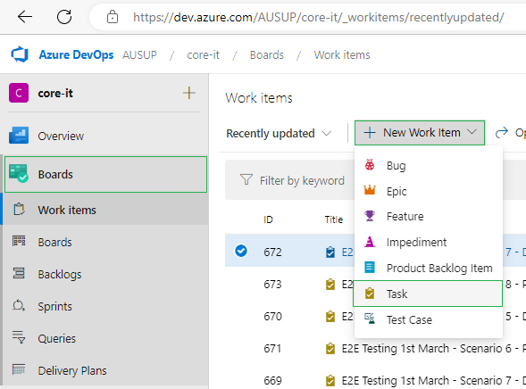

1. On NEW TASK window, enter a title, add the tag **request: non-production** for Non-Production request and **request: production** for Production request, then click on ‘Attachments’.

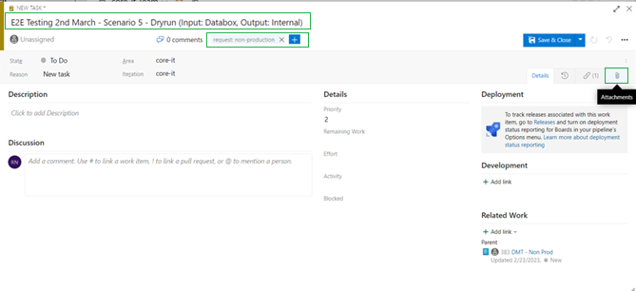

1. Click on ‘Add attachment’.

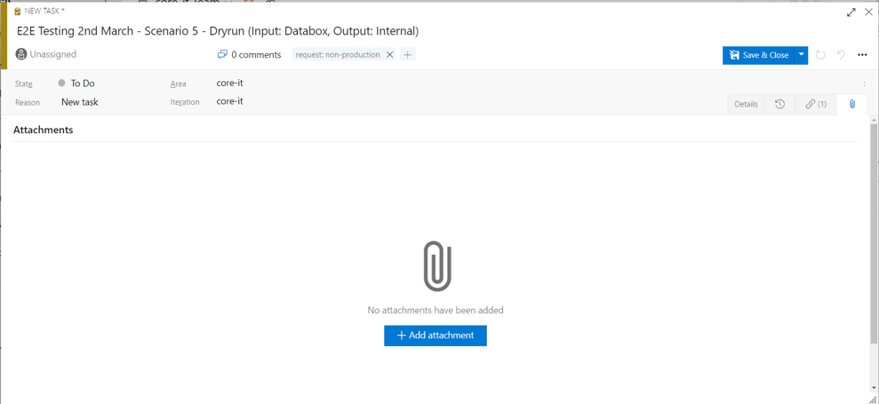

1. Navigate to the location of the input parameter file saved on your local machine then click ‘Open’.

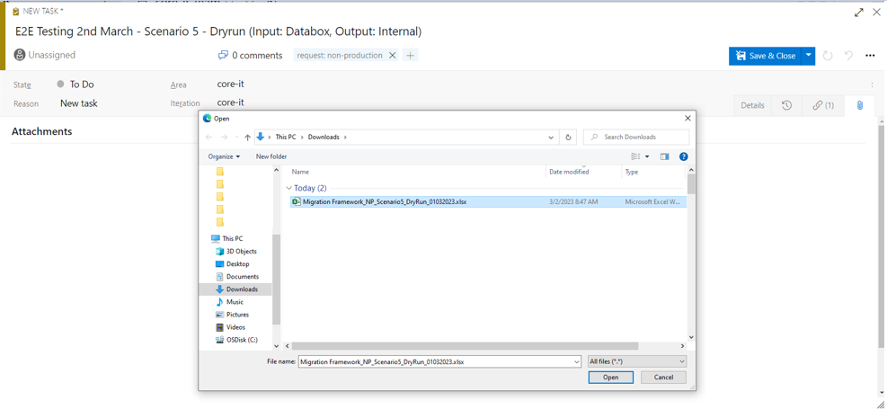

1. Once required fields on NEW TASK window are filled and file is attached, click on Save & Close.

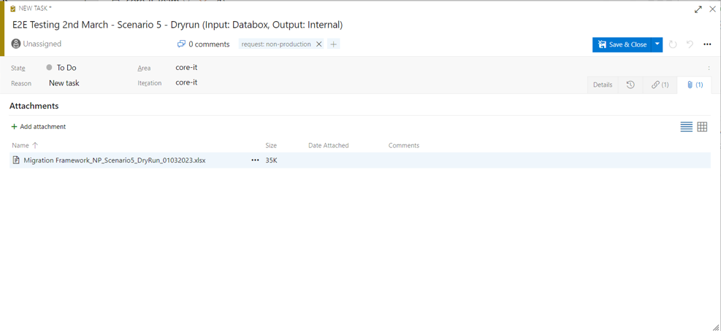

1. Once new task is created, confirm that trigger pipeline is automatically initiated.

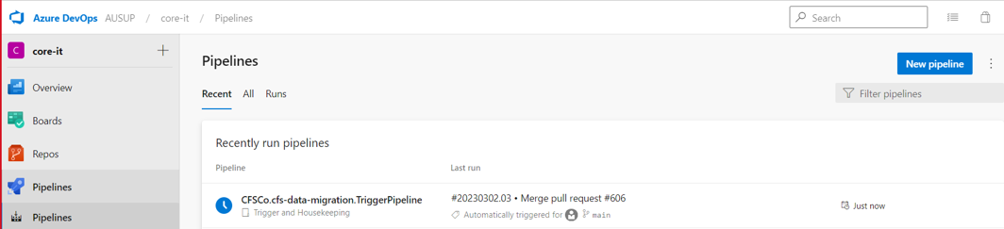

## FAQs

This section provides information regarding the frequently asked questions (FAQs) and most common errors that user may encounter during the execution of pipelines

### Trigger Pipeline

#### Failure triggering of the pipeline upon work item creation

Common Cause of Issue:

* Work Item Task created doesn’t have the required tags: **request: non-production** for Non-Production deployment request and **request: production** for Production deployment request.

**Solution:**

* 1. Create a new task with the required tags.
* Azure Services for Service Hook, Service Connection or Pipelines is down.

**Solution:**

* 1. Go to: <https://status.dev.azure.com/_history> to check if there is a down time pertaining for the services mentioned.
* Service Hook has been disabled to deleted.

**Solution:**

* 1. Go to <https://dev.azure.com/AUSUP/core-it/_settings/serviceHooks> to check if the following service hooks is present: 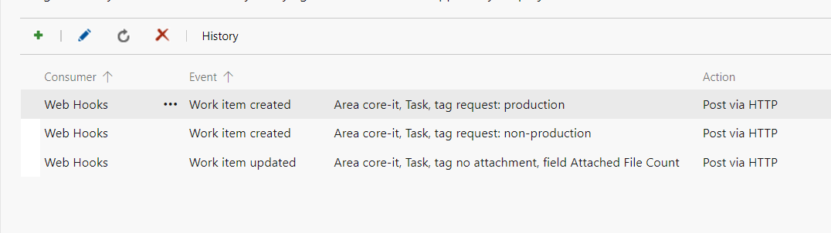
  2. Click the ellipsis button (**…**) to check if it’s been disabled or not.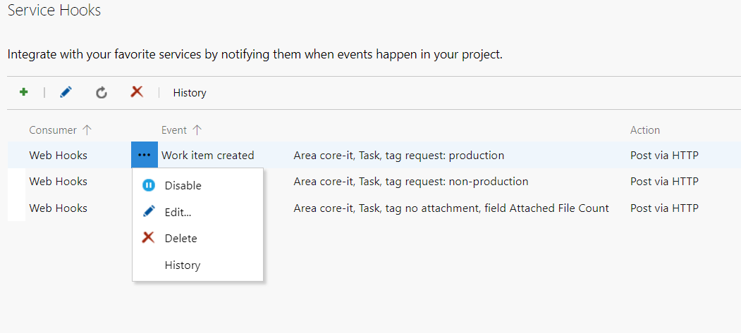
  3. If deleted, please follow below steps to re-create the needed Service Hook:
     1. For Non-Prod Service Hook creation request:
        + Click the + button to create a new service hook.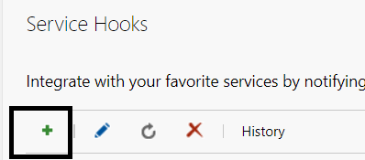
        + Select ‘Web Hooks’ Service and click ‘Next’. 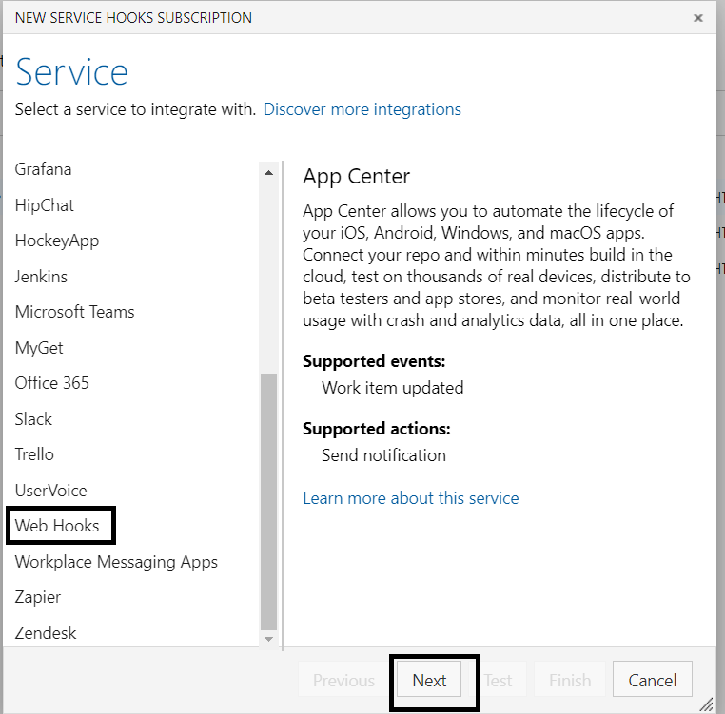
        + Select the event to trigger on and the necessary filters then click ‘Next’: 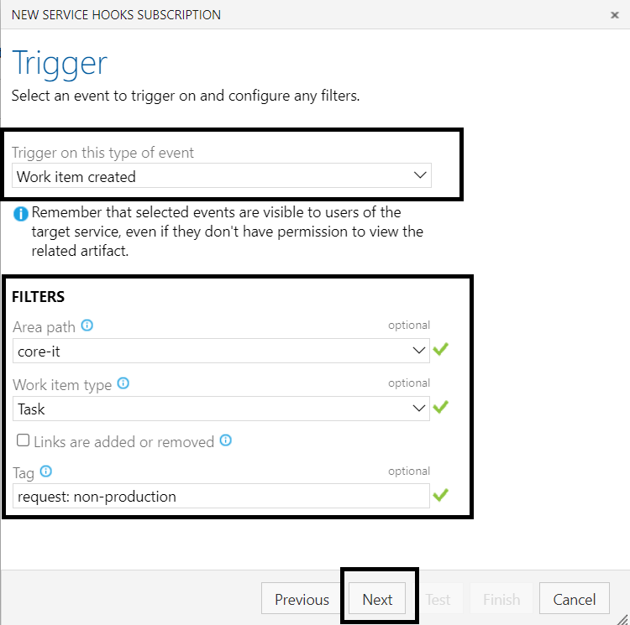
        + Under URL enter: <https://dev.azure.com/AUSUP/_apis/public/distributedtask/webhooks/TriggerPipelineWebHook?api-version=6.0-preview>

where TriggerPipelineWebHook is the name of the Service Connection then click ‘Finish’

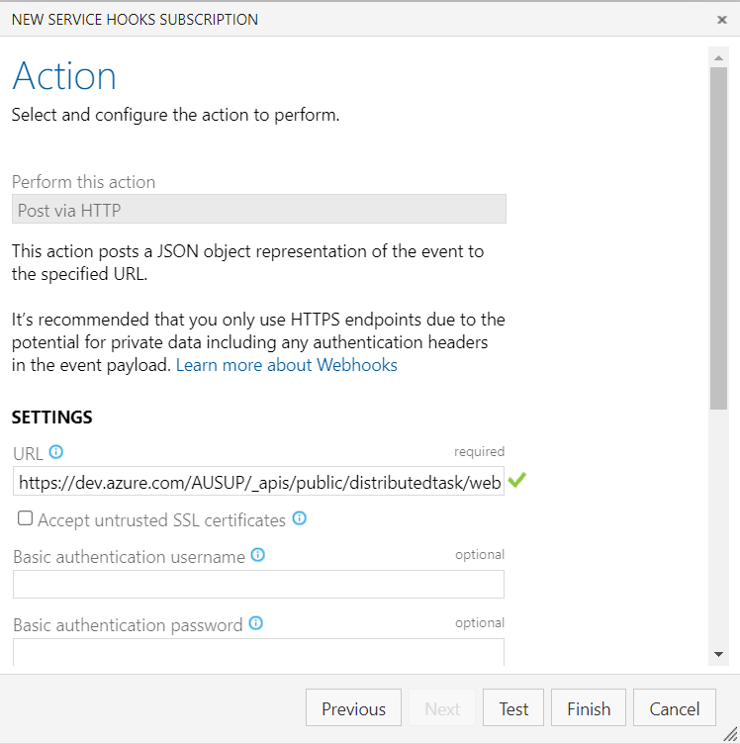

* + 1. For Prod Service Hook creation request:
       - Click the + button to create a new service hook.
       - Select ‘Web Hooks’ Service and click ‘Next’. 
       - Select the event to trigger on and the necessary filters then click ‘Next’: 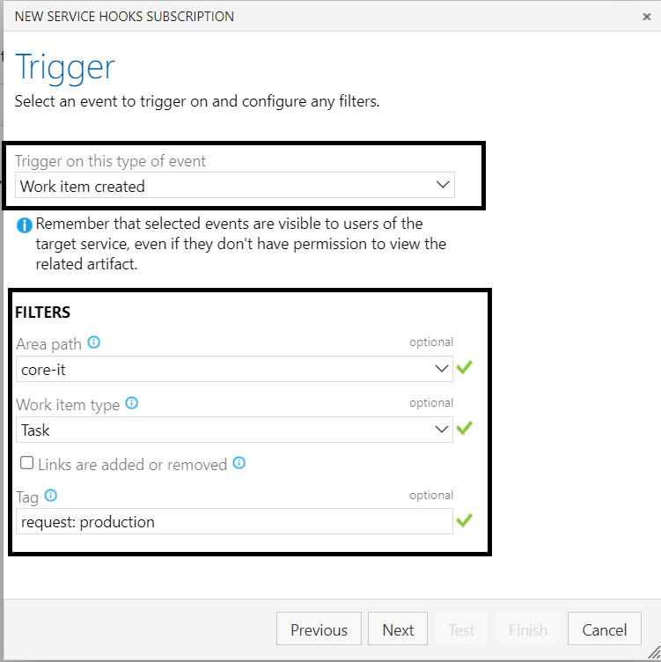
       - Under URL enter: <https://dev.azure.com/AUSUP/_apis/public/distributedtask/webhooks/TriggerPipelineWebHook?api-version=6.0-preview>

where TriggerPipelineWebHook is the name of the Service Connection then click ‘Finish’



* + 1. For Service Hook update request:
       - Click the + button to create a new service hook.
       - Select ‘Web Hooks’ Service and click ‘Next’. 
       - Select the event to trigger on and the necessary filters then click ‘Next’: 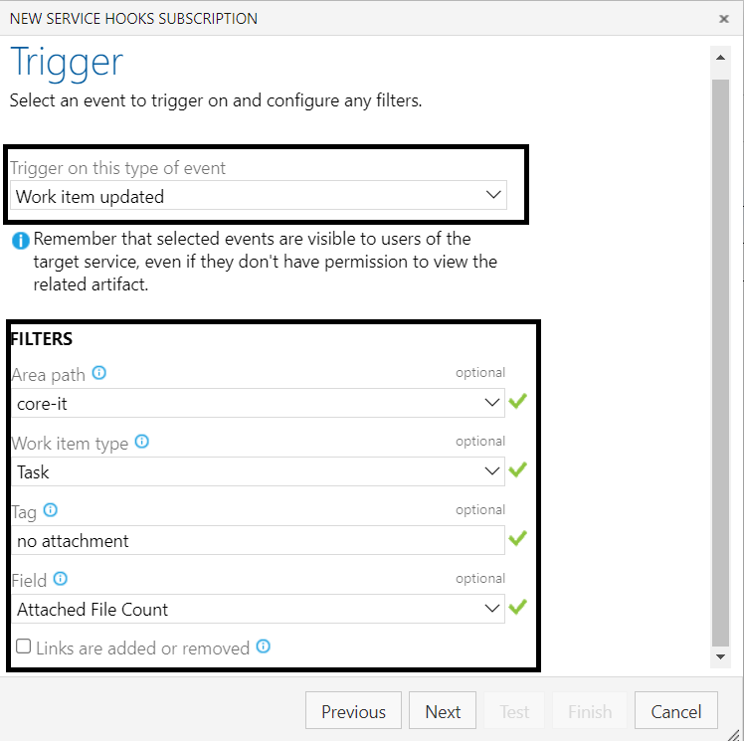
       - Under URL enter: <https://dev.azure.com/AUSUP/_apis/public/distributedtask/webhooks/TriggerPipelineWebHook?api-version=6.0-preview>

where TriggerPipelineWebHook is the name of the Service Connection then click ‘Finish’



* Service Connection has been deleted.

**Solution:**

* 1. Go to <https://dev.azure.com/AUSUP/core-it/_settings/adminservices> and check if TriggerPipeline service connection is still present: 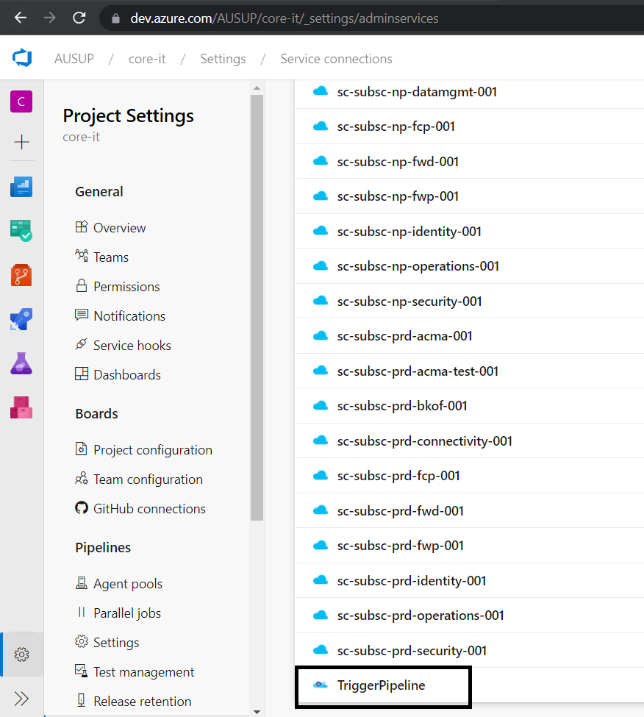
  2. If TriggerPipeline is no longer present, re-create the Service Connection by following the steps:
     1. Click ‘New service connection button’: 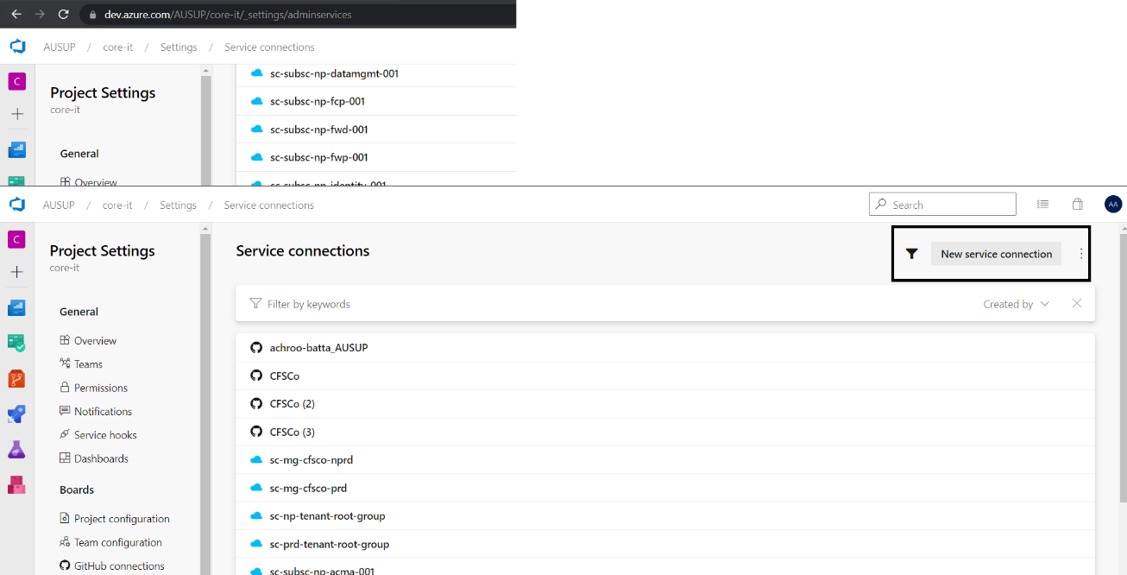
     2. Select ‘Incoming WebHook’  
        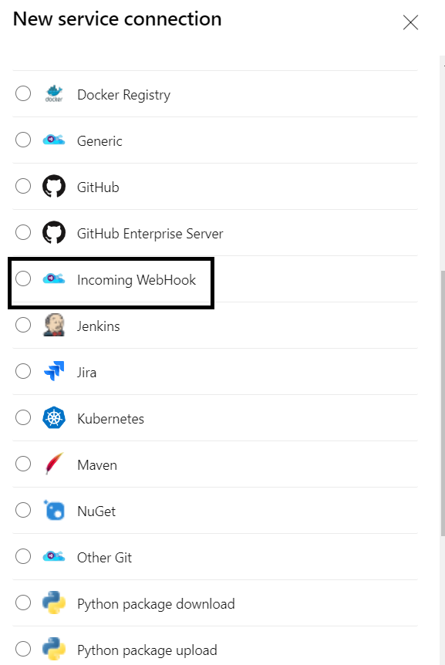
     3. Click ‘Next’ and provide the following details before clicking ‘Save’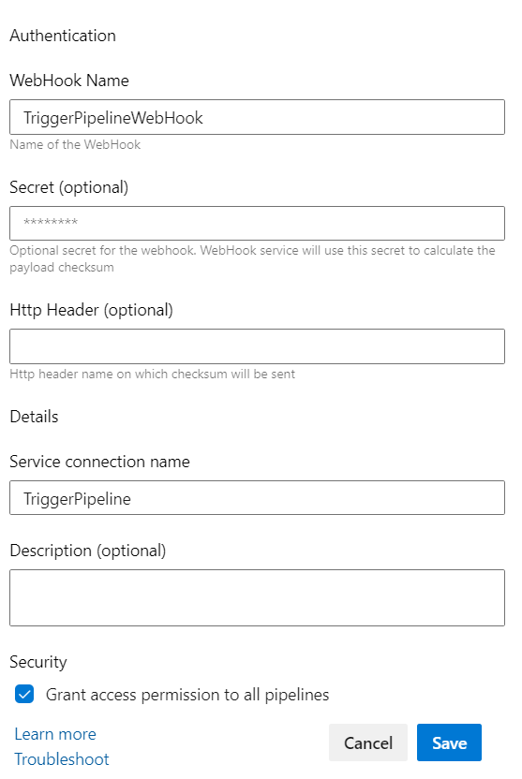

#### Failure in downloading the input parameter file from work item task

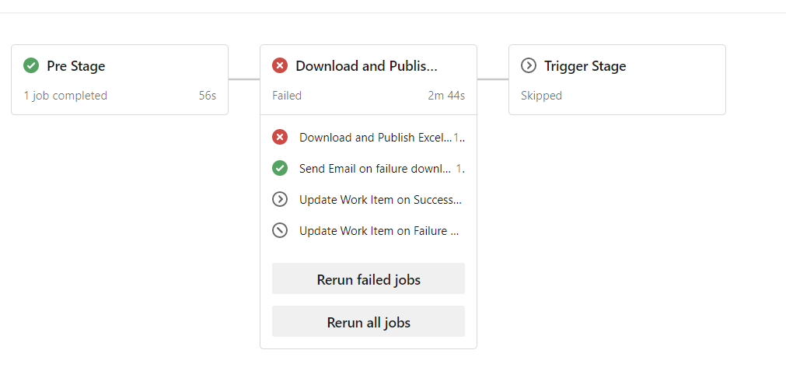

Common Cause of Issue:

* No attachment found in the work item task.

**Solution:**

* 1. Requestor will receive an email saying that parameter file is missing and will contain a link where they can access the work item and add the input parameter file as an attachment. 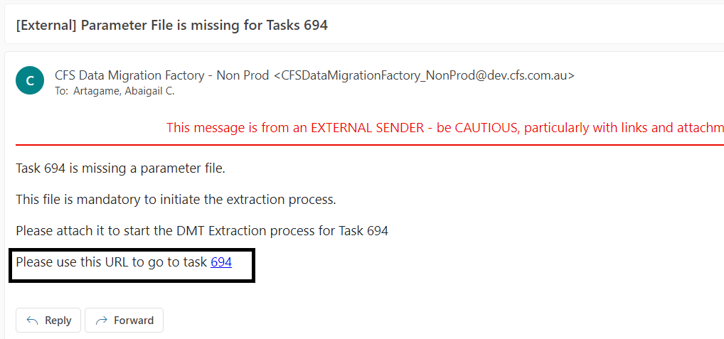
  2. Attach the missing input parameter file by following below steps:
     1. Click the work item URL included in the email. This will open the work item task in a browser.
     2. Upload the Input Parameter file from your local computer by going to the Attachment tab and clicking + Add Attachment button. 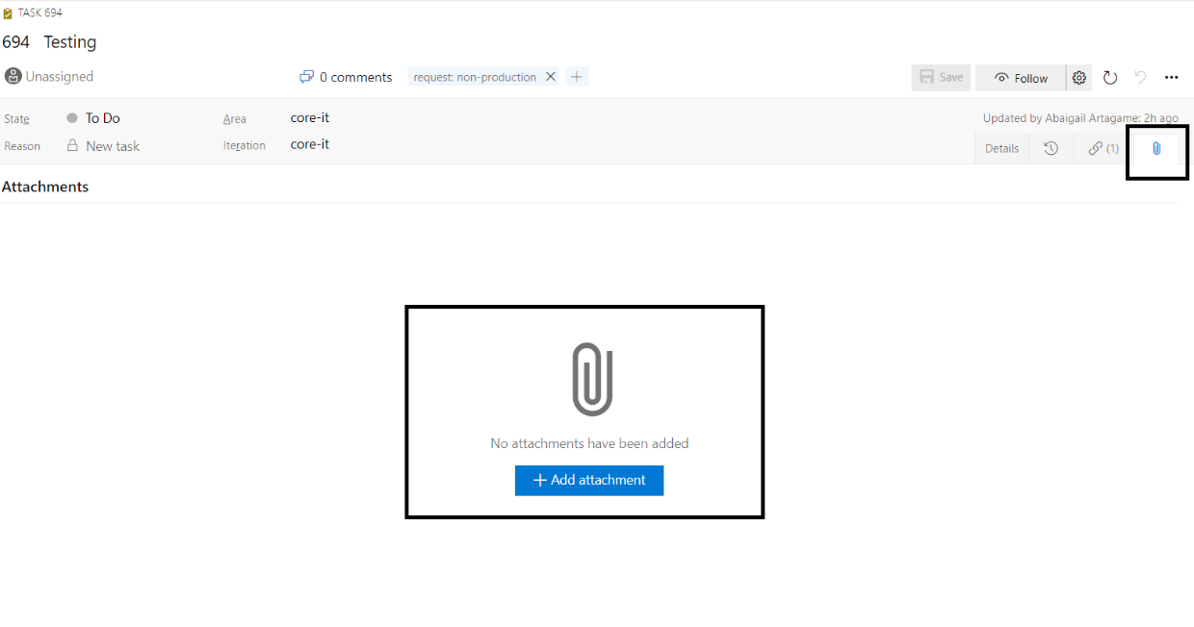

#### Failure mapping of variables

Common cause of issue:

* Input Parameter Excel File Required Columns is missing.

**Solution:**

* 1. Check if Column C with name “VariableName in Pipeline” and Column E with name “Values” is present in the uploaded input parameter excel file under Input Fields Sheet.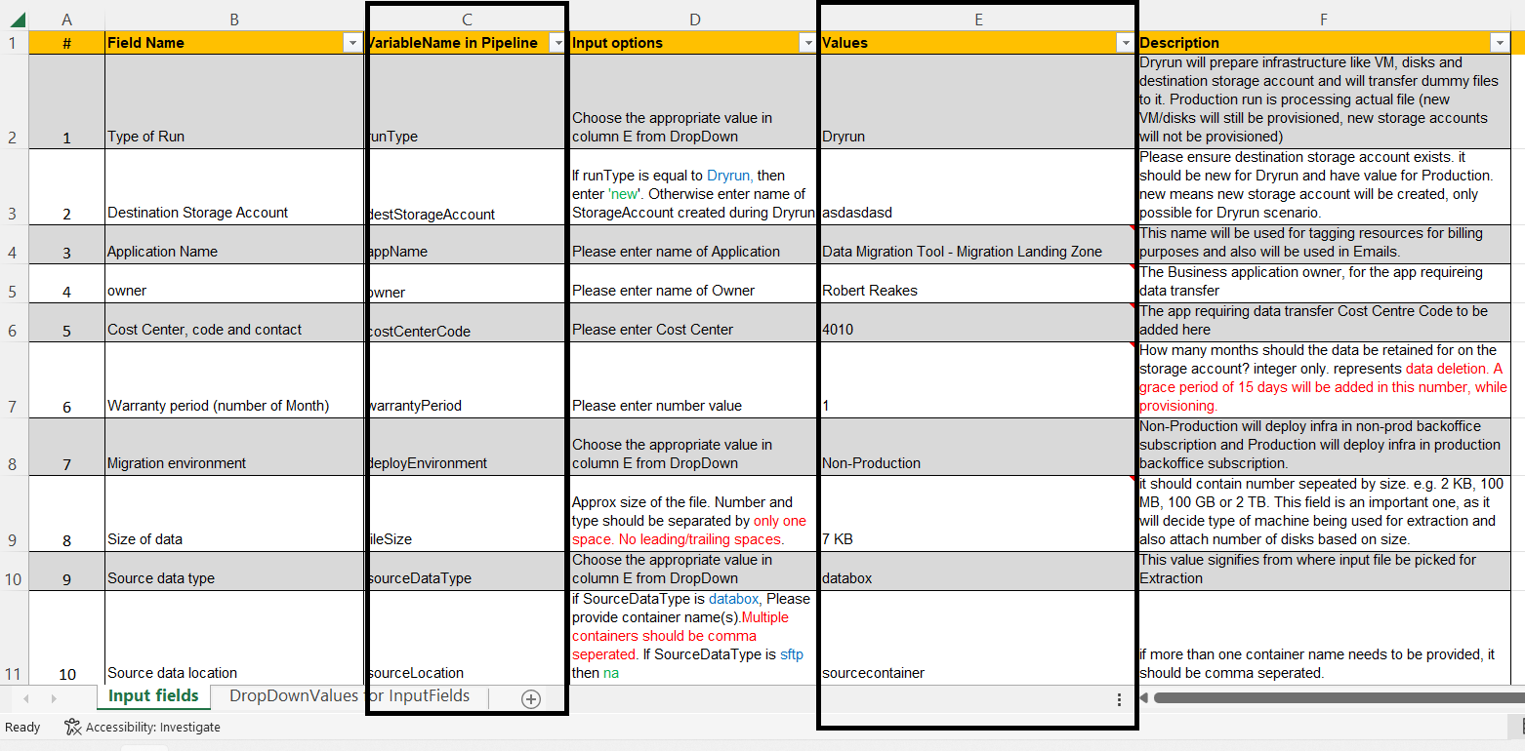

#### Failure triggering of OnDemand Pipeline

Common cause of issue:

* Missing required Values in the Input Parameters Files.

**Solution:**

* 1. Check if there are lacking values in the Column E of the uploaded input parameter excel file. 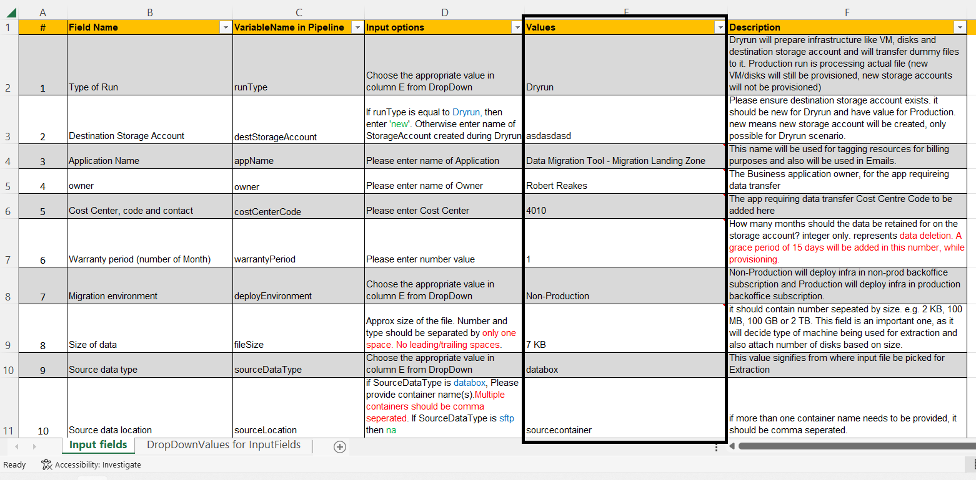

#### Failure to send email notification

Common cause of issue:

* Needed details for sending of the email is inaccurate:

**Solution:**

* 1. Go to:

<https://dev.azure.com/AUSUP/core-it/_library?itemType=VariableGroups&view=VariableGroupView&variableGroupId=61&path=var-password>

* 1. Verify the following variables has the correct values:
     1. npAdReceiverEmail – Non-Prod AD group email address
     2. npClientId – Non-Prod Client ID for Service Account
     3. npClientSecret - Non-Prod Client Secret for Service Account
     4. npDefaultReceiverEmail – Non-Prod Default email address where the email will be sent if requestor failed to attach the input parameter file
     5. npFromEmail – Service Account email address
     6. npTenantDomain – Non-Prod Tenant Id
     7. prdAdReceiverEmail –-Prod AD group email address
     8. prdClientId - Prod Client ID for Service Account
     9. prdClientSecret - Prod Client Secret for Service Account
     10. prdDefaultReceiverEmail - Prod Default email address where the email will be sent if requestor failed to attach the input parameter file
     11. prdTenantDomain - Prod Tenant Id
     12. techSupportEmailAddress – Tech support email address

#### Failure to update work item status and add a work item comment.

Common cause of issue:

* PAT has already expired or not in the variable group.

**Solution:**

* 1. Go to:

<https://dev.azure.com/AUSUP/core-it/_library?itemType=VariableGroups&view=VariableGroupView&variableGroupId=67&path=var-parameter-dm-grp>

* 1. Check if PAT variable is present and update the correct value for PAT. If PAT is no longer there, create a new variable by clicking the + Add button and add ‘PAT’ as name.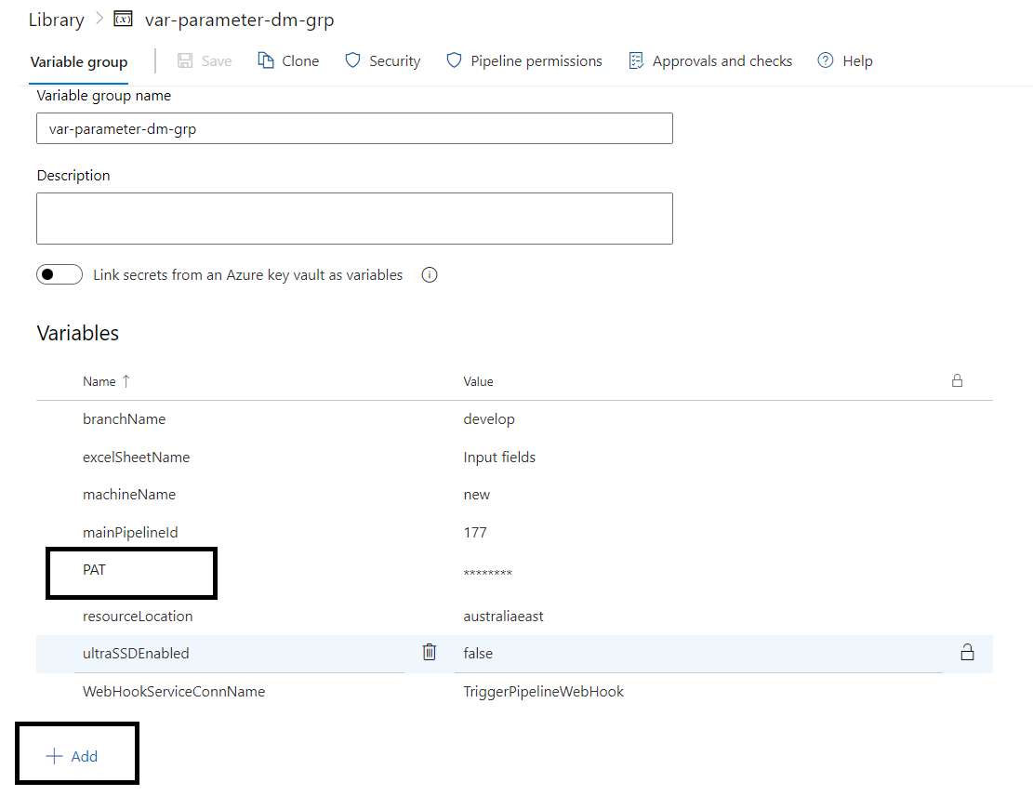

### OnDemand Pipeline

#### Failure on VM Deployment due to Diagnostic issue

**Problem:**

Pipeline may fail on ‘Deploy VM’ stage for the deployment of virtual machine in BKOF Subscription due to error on provisioning VM Extension particularly for VM Diagnostic Settings.

Below are the error details:

*ERROR: {"status":"Failed","error":{"code":"DeploymentFailed","message":"At least one resource deployment operation failed.*

*code: "VMExtensionProvisioningError"*

*message: "VM has reported a failure when processing extension 'Microsoft.Insights.VmDiagnosticsSettings-stonpedcbkof002'.*

*Error message: "Got exception while doing network call.*

**Screenshots:**

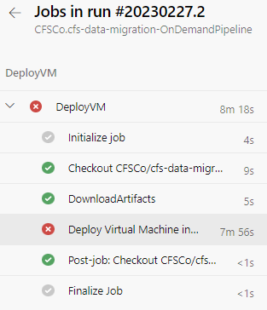

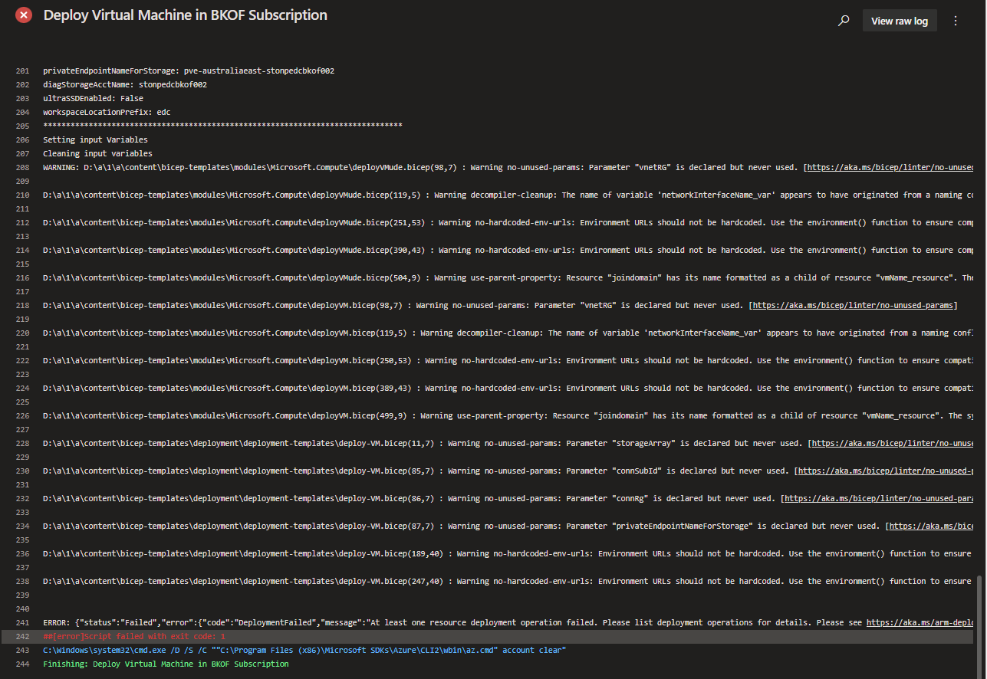

**Solution:**

Restart OnDemand Pipeline

* + - 1. Go to Pipelines. On Runs tab, Click on the OnDemandPipeline run that failed

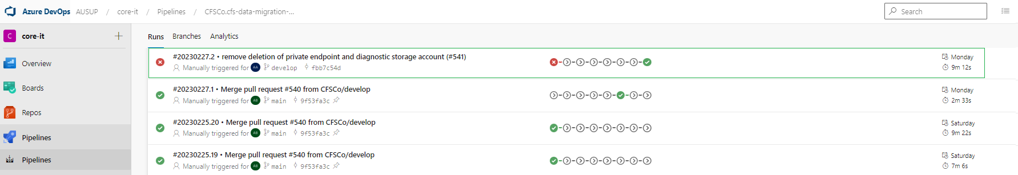

* + - 1. Click on ‘Run new’ to open Run Pipeline window

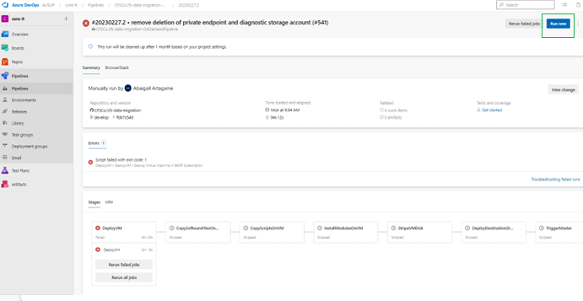

* + - 1. Click ‘Run’ as there’s no need to change input values.

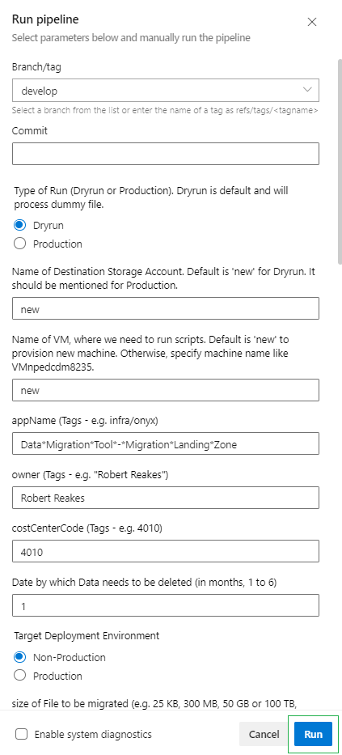

#### Failure on Copy Stage as server name cannot be resolved

**Problem:**

There are times that copy stage fails because Secondary domain controller is not refreshed with VMname. We have put logic to retry for 20 mins. If it still fails after that duration. Something is wrong in Domain Controller.

*Error:*

*The WinRM client cannot process the request because the server name cannot be resolved.*

**Screenshots:**

*Re-try Logic*

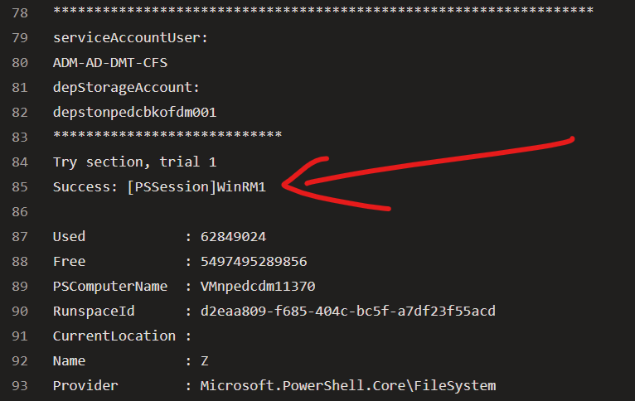

*Error*

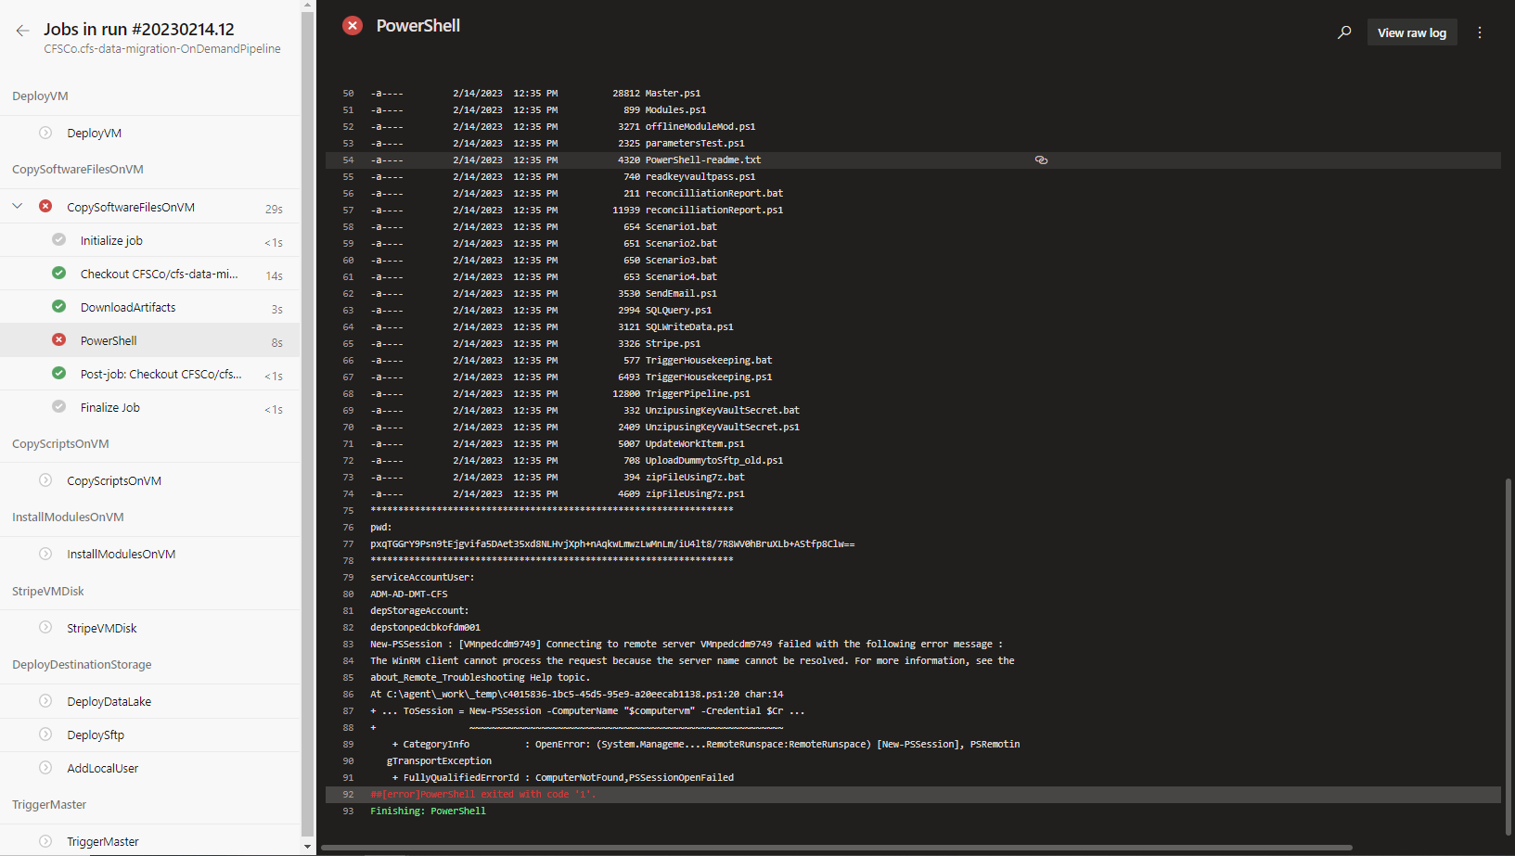

**Solution:**

Restart OnDemand Pipeline

1. Go to Pipelines. On Runs tab, Click on the OnDemandPipeline run that failed

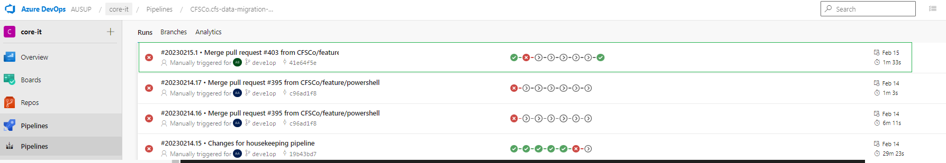

1. Click on ‘Run new’ to open Run Pipeline window

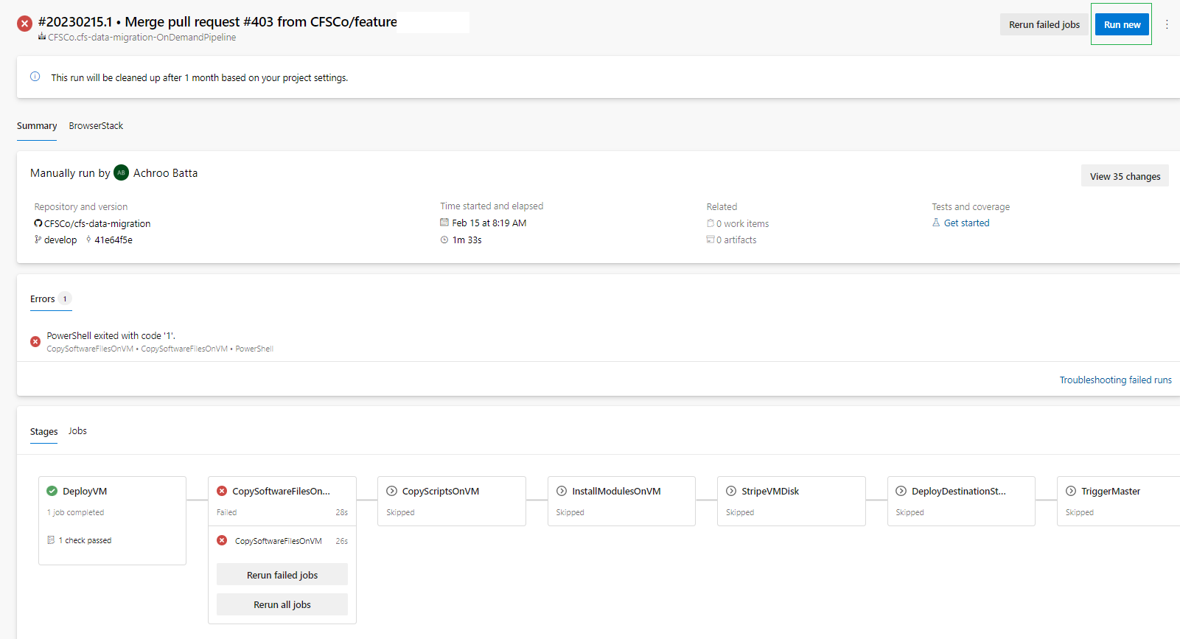

1. Click ‘Run’ as there’s no need to change input values.



#### Failure on Deploy Destination Storage (SFTP) Stage due to Connect-AzAccount

**Problem:**

Pipeline may fail on ‘DeployDestinationStorage’ stage for the creation of SFTP Local user because of issue with connecting to Azure particularly execution of Connect-AzAccount.

Below are error details:

*An error occurred while sending the request.*

*CategoryInfo : CloseError: [Connect-AzAccount], HttpRequestException*

*FullyQualifiedErrorId : Microsoft.Azure.Commands.Profile.ConnectAzureRmAccountCommand*

**Screenshots:**

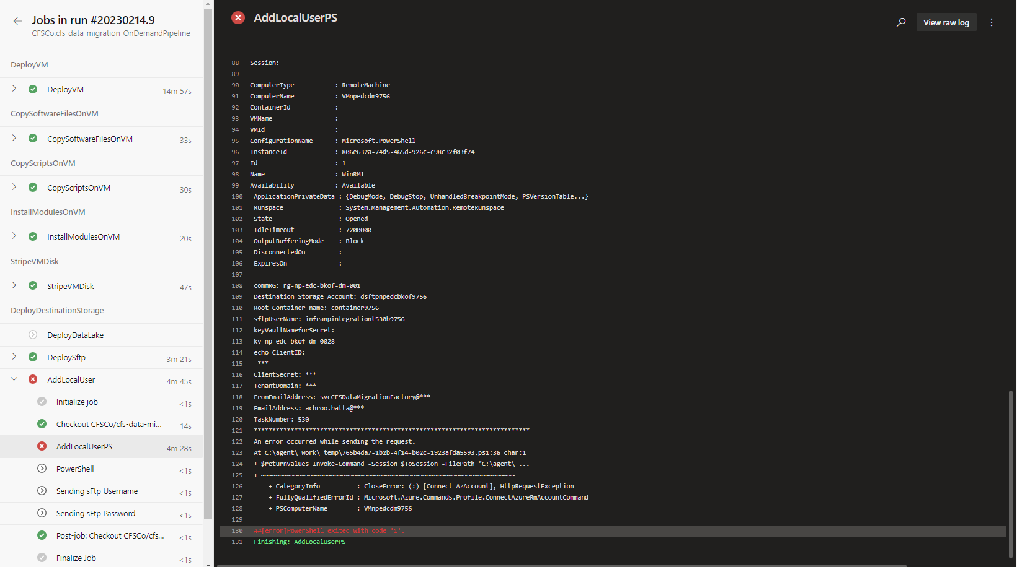

**Solution:**

Restart OnDemand Pipeline

1. Go to Pipelines. On Runs tab, Click on the OnDemandPipeline run that failed

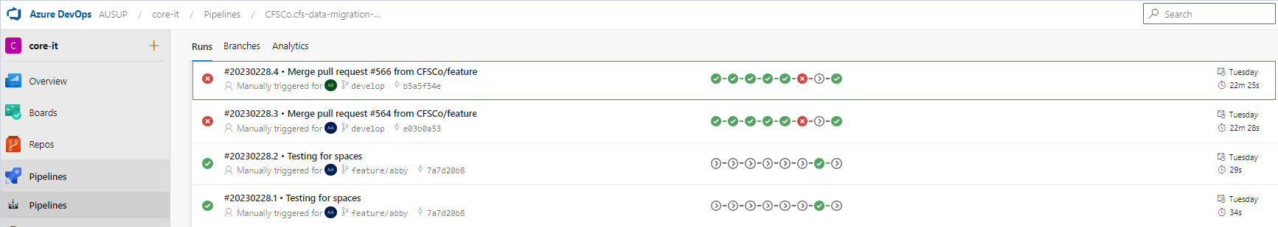

1. Click on ‘Run new’ to open Run Pipeline window

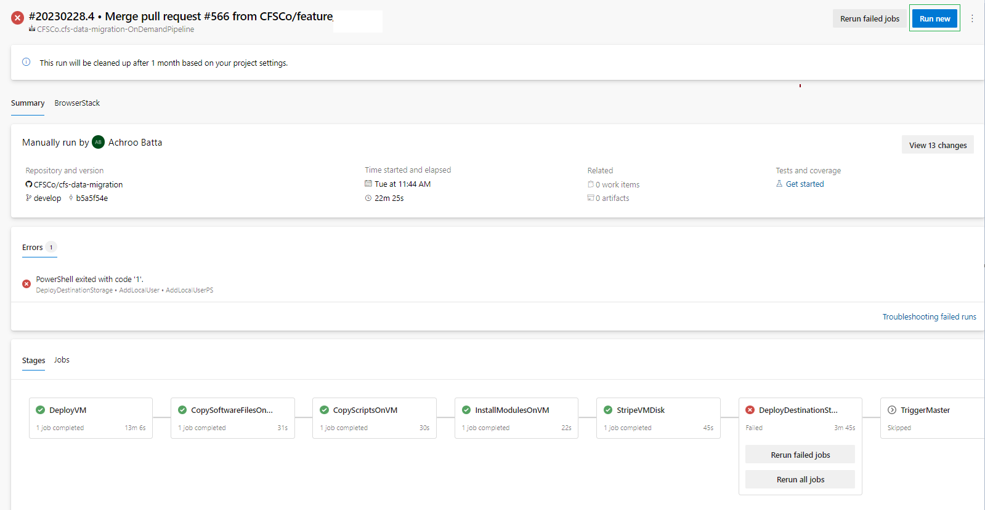

1. Click ‘Run’ as there’s no need to change input values.



### Powershell Scripts

9.3.3.1  *Failure to copy input files from source databox to source disk in virtual machine.*

***Problem****:*

There will be error in copying the files from databox to disk if the container is not available or non-existing.

***Screenshot****:*

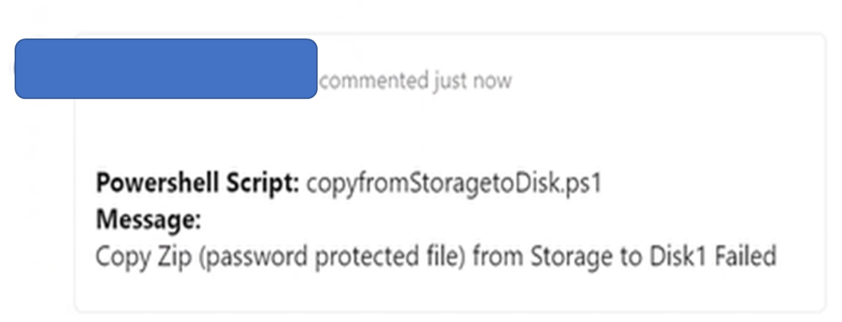

**Solution**:

1. Check the input container name in the parameter files.



2. Validate if the specified container name exists in the databox. If the input container value is not in the

storage account, update the param file with the container available in databox.

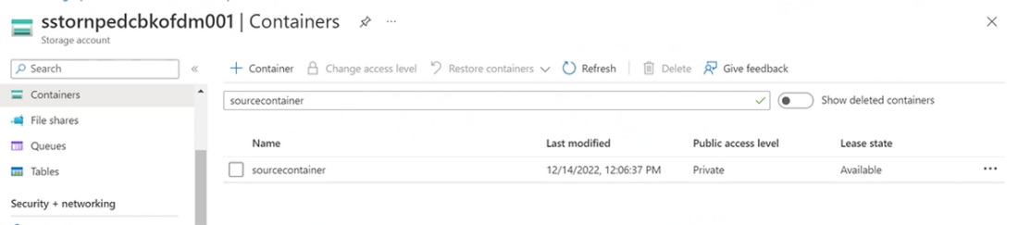

9.3.3.2 *Failure to get key vault secret for input file (extracted files).*

**Problem**:

No password will be used in the extracted files.

**Screenshot**:

*This log can be seen in Work item at DevOps.*

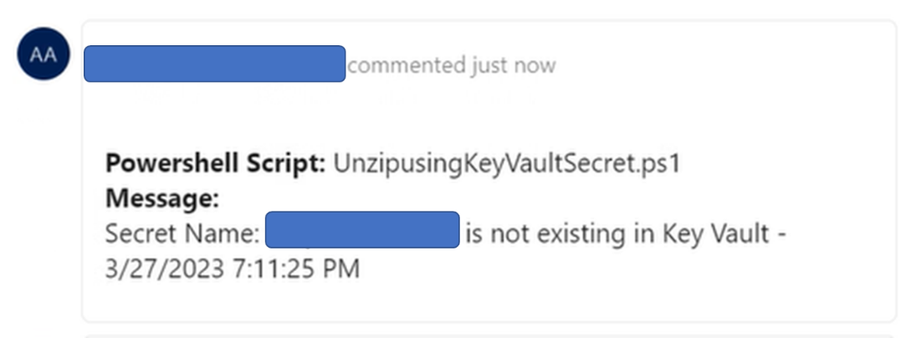

**Solution**:

1. Check the input secret name value in the parameter files.



1. Validate if the specified secret name exists in the key vault. If the secret name value is not in the key vault, update the param file with the secret name available in key vault.

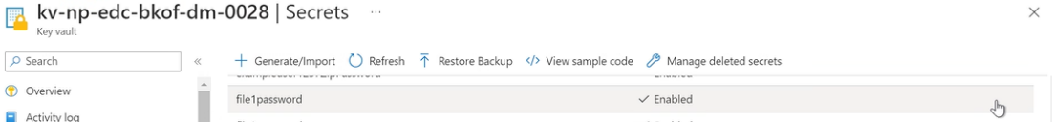

9.3.3.3 *Failure to connect to SFTP due incorrect credentials.*

**Problem**:

Unable to connect to SFTP server due to incorrect SFTP credentials to get files.

**Screenshot**:

*This log can be seen in Work item at DevOps.*

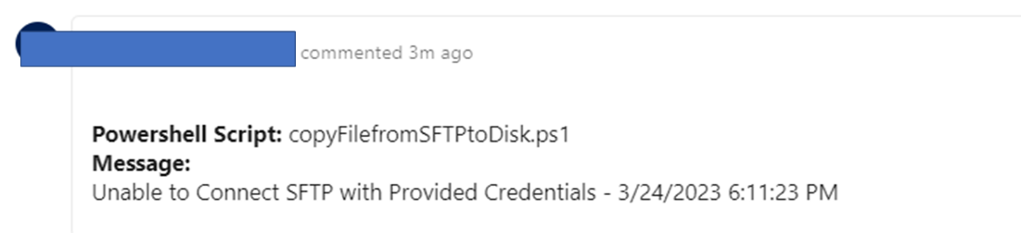

**Solution**:

1. Check the input sftp credential value in the parameter files.

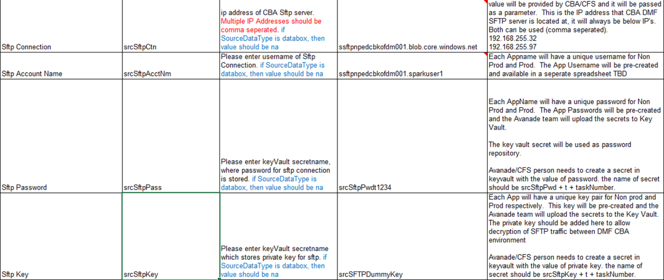

1. Validate if the specified sftp credentials (SSH Key/Password) exists in the key vault. If the sftp credentials value is not in the key vault, update the param file with the sftp credentials available or correct value in key vault.

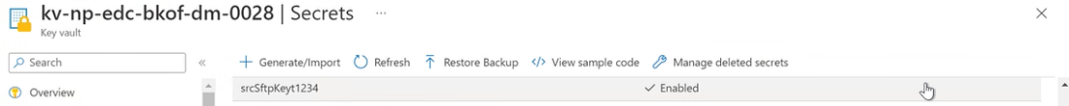

9.3.3.4 Process Stopped due to Incorrect Destination Storage Account

**Problem**:

Script detected that Storage account is not existing inside the Resource Group.

**Screenshot**:

*This log can be seen in Work item at DevOps.*

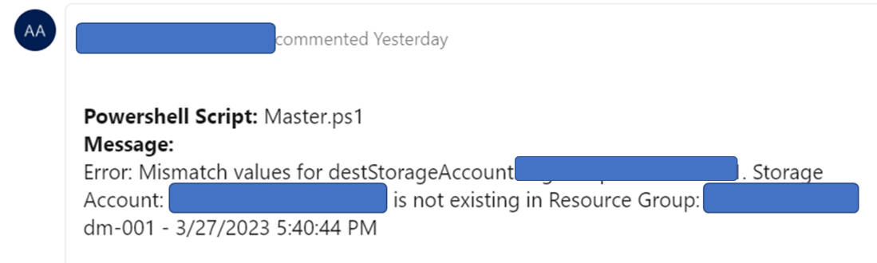

**Solution**:

1. Check the input Destination Storage Account value in the parameter files.  
   
2. Validate if the specified Storage Account exists in the Resource Group. If it's not existing, select available storage account and update the param file.  
   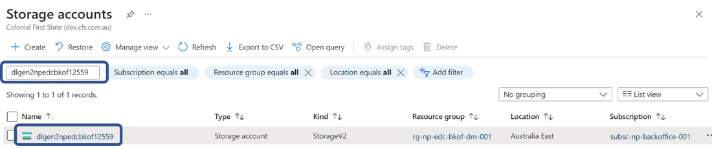

9.3.3.5 *Failure to log information in DevOps work item.*

**Problem**:

Unable to log in DevOps work item.

***Note****: Script is not capable to check if the PAT is already expired*

**Screenshot**:

*This log can be seen in spined virtual machine. Please refer to Master Powershell script monitoring.*

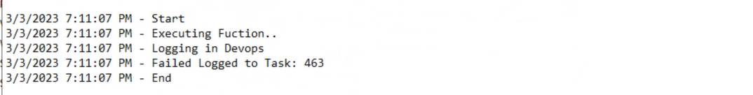

**Solution**:

1) Check if PAT exists in key vault.

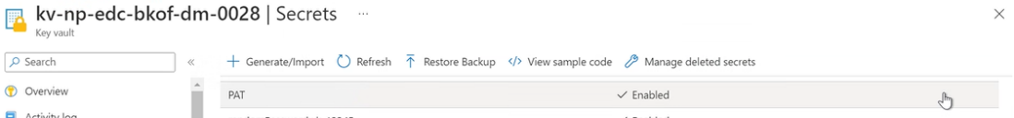

2) If PAT exists, update the secret value. Click the “+ New Version”.

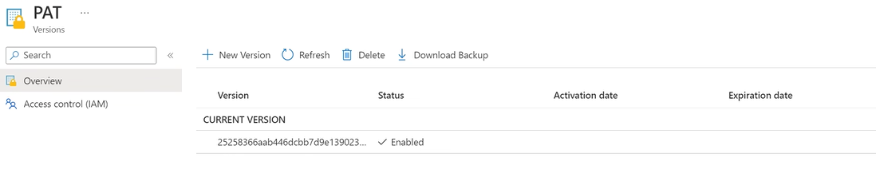

Paste the value copied from Personal Access Token in DevOps to Secret value field.

Then click create button.

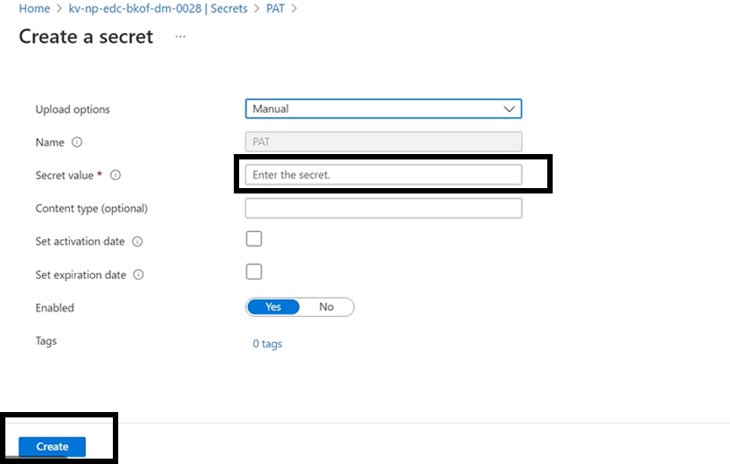

9.3.3.6 *Failure to extract file due to incorrect secret value.*

**Problem**:

Unable to extract files due to incorrect secret value

**Screenshot**:

*This log can be seen in Work item at DevOps.*

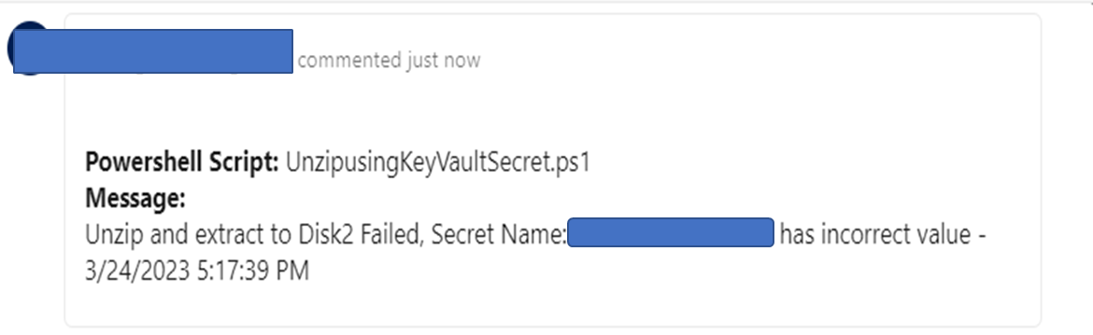

**Solution**:

1. Check the input secret name value in the parameter files.



1. Search the secret name in key vault.

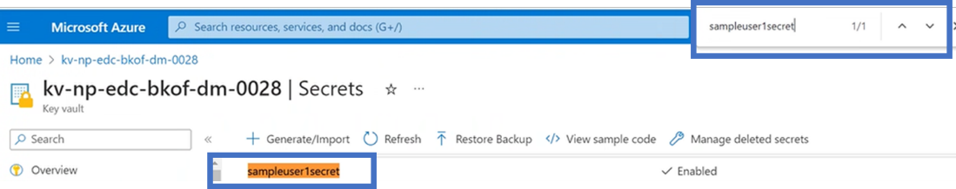

1. Click the current version

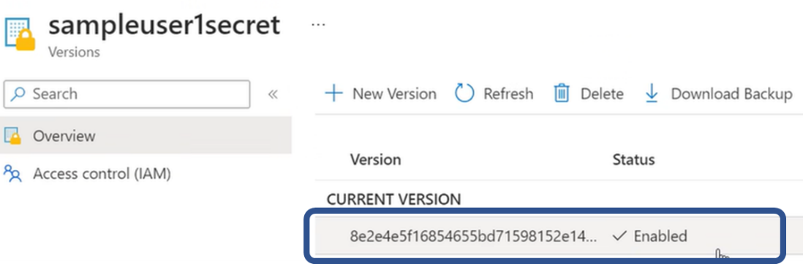

Click the Show Secret Value to show the current secret value. If the value is not correct follow the next step.

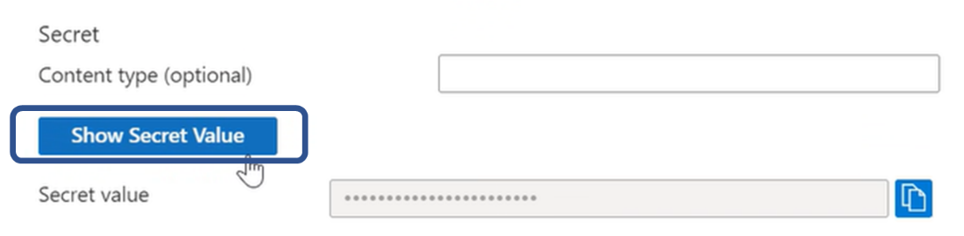

1. Update the secret name with correct value/password. Click the “New Version” button.

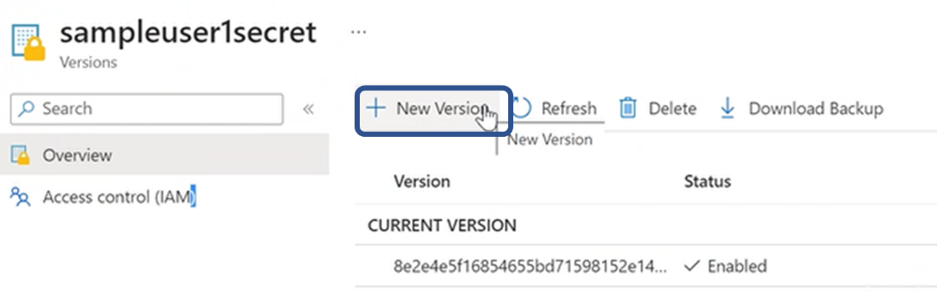

Fill up the Secret value field and click the “Create” button

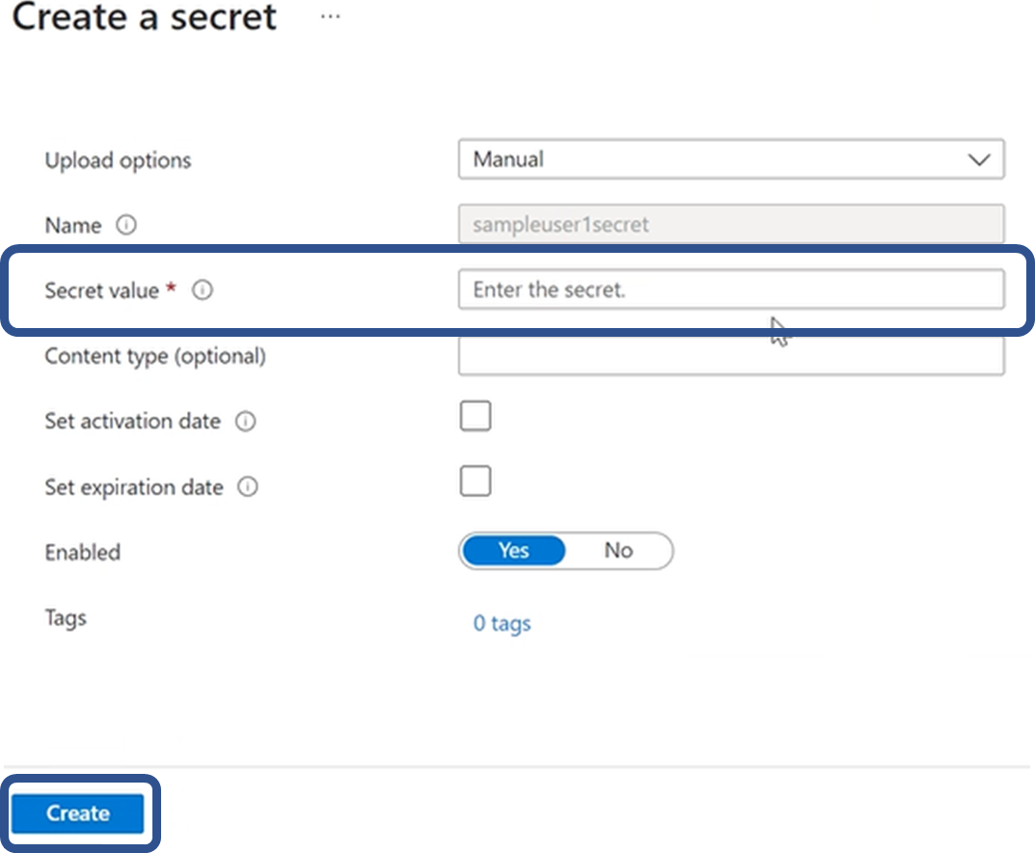

### Housekeeping Pipeline

#### Failure to get key vault secret for SFTP Zip File(s) password

Common cause of issue:

* zipFileSecretName parameters has not been passed correctly. This is an indication that there is something wrong with the PowerShell scripts execution.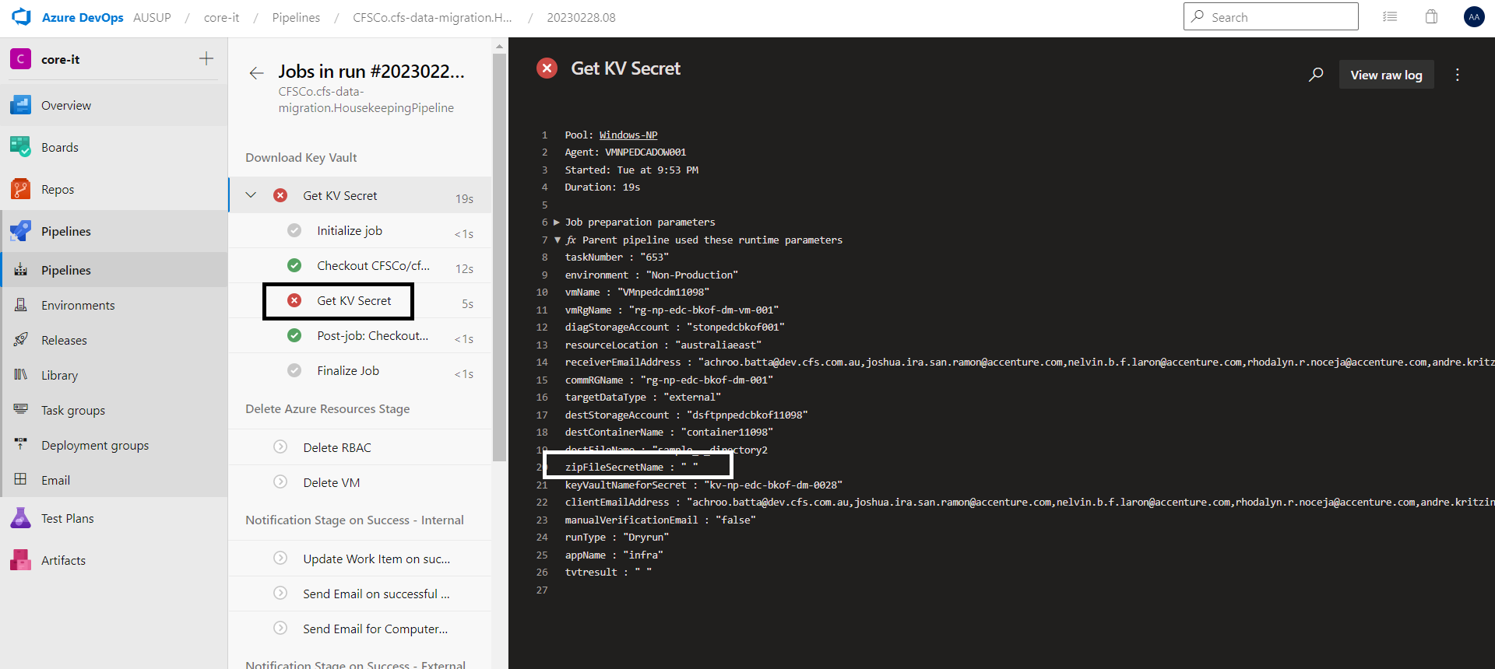

**Solution:**

* 1. Check the PowerShell logs in the Azure DevOps task if there is a problem occurred in the execution.

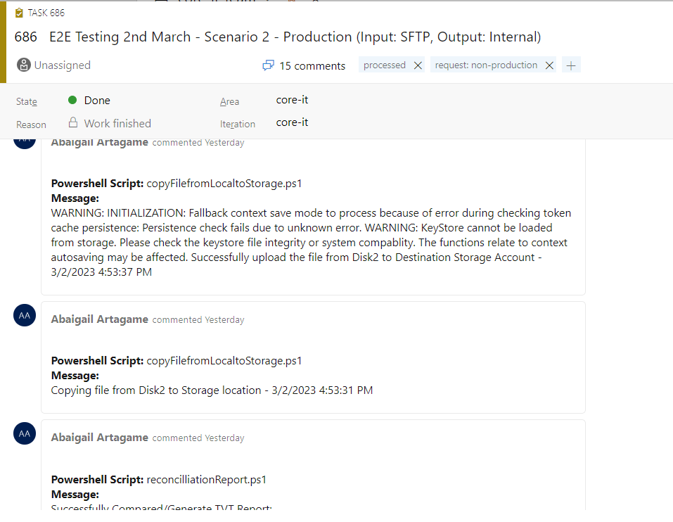

* Issue in Azure Connection. 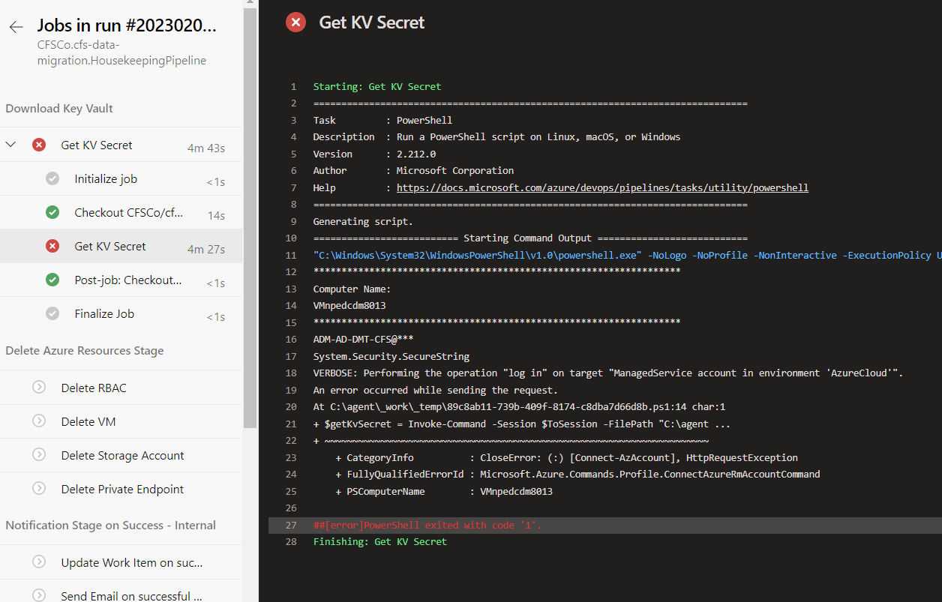

**Solution:**

* 1. Run the Housekeeping pipeline with the correct parameters.
     1. Go to [Housekeeping Pipeline](https://dev.azure.com/AUSUP/core-it/_build?definitionId=152&_a=summary) and click Run Pipeline button.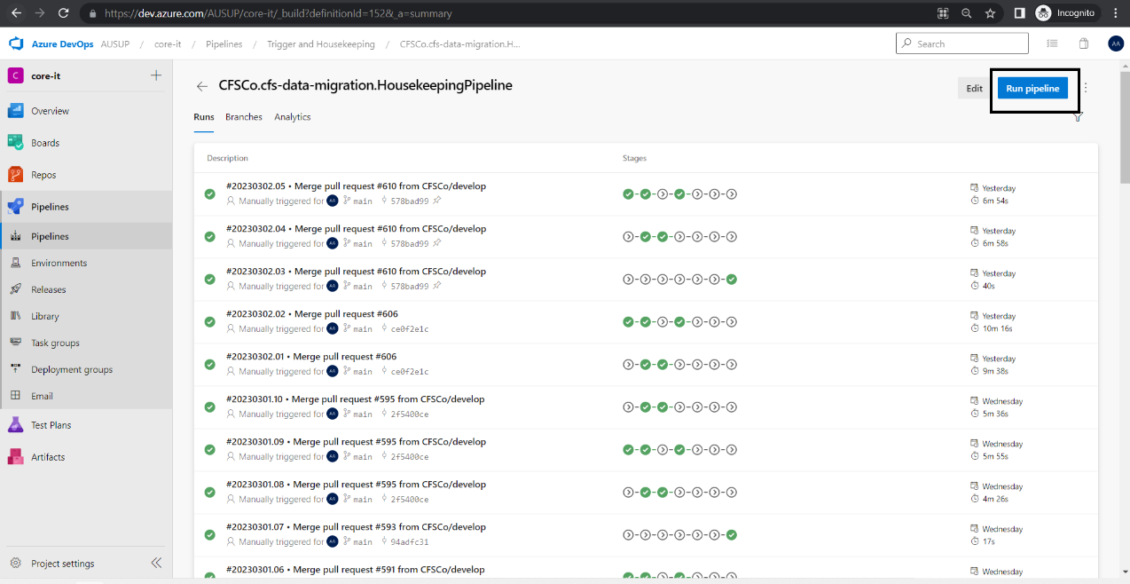
     2. Provide the required parameters and click ‘Run’. 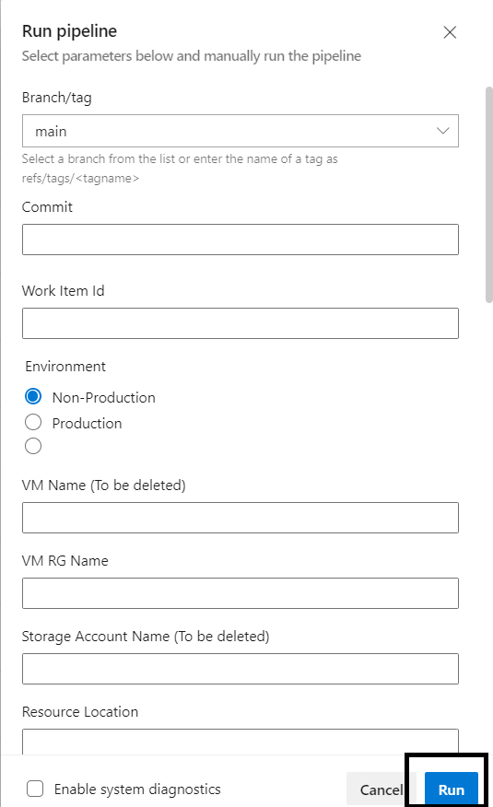

#### Failure in VM and VM Role Deletion.

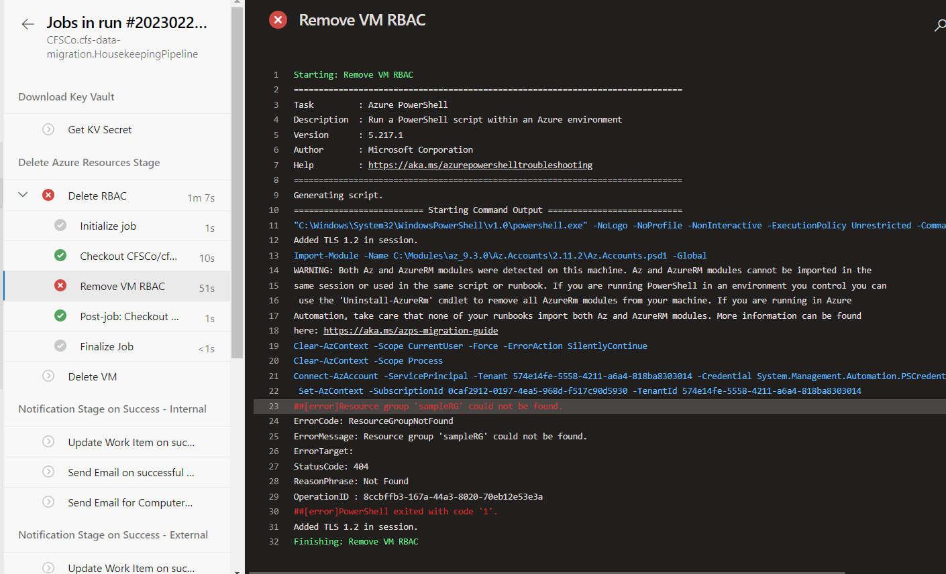

Common cause of issue:

* VM details has not been passed correctly. 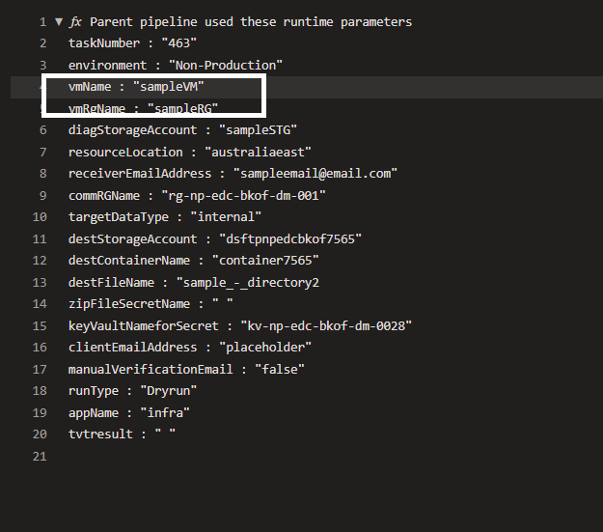

**Solution:**

* 1. Trigger the Housekeeping Pipeline with the right parameters.
  2. Run the Housekeeping pipeline with the correct parameters.
     1. Go to [Housekeeping Pipeline](https://dev.azure.com/AUSUP/core-it/_build?definitionId=152&_a=summary) and click Run Pipeline button.
     2. Provide the required parameters and click ‘Run’. 

#### Failure to send email notification

Common cause of issue:

* Needed details for sending of the email is inaccurate:

**Solution:**

* 1. Go to:

<https://dev.azure.com/AUSUP/core-it/_library?itemType=VariableGroups&view=VariableGroupView&variableGroupId=61&path=var-password>

* 1. Verify the following variables has the correct values:
     1. npAdReceiverEmail – Non-Prod AD group email address
     2. npClientId – Non-Prod Client ID for Service Account
     3. npClientSecret - Non-Prod Client Secret for Service Account
     4. npDefaultReceiverEmail – Non-Prod Default email address where the email will be sent if requestor failed to attach the input parameter file
     5. npFromEmail – Service Account email address
     6. npTenantDomain – Non-Prod Tenant Id
     7. prdAdReceiverEmail –-Prod AD group email address
     8. prdClientId - Prod Client ID for Service Account
     9. prdClientSecret - Prod Client Secret for Service Account
     10. prdDefaultReceiverEmail - Prod Default email address where the email will be sent if requestor failed to attach the input parameter file
     11. prdTenantDomain - Prod Tenant Id
     12. techSupportEmailAddress – Tech support email address

#### Failure to update work item status and add a work item comment.

Common cause of issue:

* PAT has already expired or not in the variable group.

**Solution:**

* 1. Go to:

<https://dev.azure.com/AUSUP/core-it/_library?itemType=VariableGroups&view=VariableGroupView&variableGroupId=67&path=var-parameter-dm-grp>

* 1. Check if PAT variable is present and update the correct value for PAT. If PAT is no longer there, create a new variable by clicking the + Add button and add ‘PAT’ as name.